Figure 7
Fixed Broadband Availability Measured by Location and Block as of June 30, 2023
(Units in thousands. Includes services of at least 100 Mbps downstream and 20 Mbps upstream)

 |  | Aggregation By Location |  | Aggregation By Block |  | Difference
Technology | Total Units | Units Covered | Ratio | Units Covered | Ratio | Difference | Ratio
Any Technology | 164,753 | 164,698 | 1.00 | 164,729 | 1.00 | 32 | 0.00
Satellite | 164,753 | 164,091 | 1.00 | 164,265 | 1.00 | 175 | 0.00
Terrestrial | 164,753 | 154,553 | 0.94 | 159,625 | 0.97 | 5,072 | 0.03
Fixed Wireless | 164,753 | 71,059 | 0.43 | 112,361 | 0.68 | 41,302 | 0.25
Licensed | 164,753 | 59,057 | 0.36 | 103,927 | 0.63 | 44,870 | 0.27
Unlicensed | 164,753 | 22,194 | 0.13 | 29,088 | 0.18 | 6,894 | 0.04
Wireline | 164,753 | 150,149 | 0.91 | 155,632 | 0.94 | 5,483 | 0.03
Copper Wire¹ | 164,753 | 7,685 | 0.05 | 30,882 | 0.19 | 23,197 | 0.14
Coaxial Cable | 164,753 | 140,610 | 0.85 | 146,625 | 0.89 | 6,014 | 0.04
Optical Carrier | 164,753 | 71,170 | 0.43 | 98,960 | 0.60 | 27,790 | 0.17
¹ Other is summarized with Copper Wire.
Note: The Aggregation by Location columns sum the number of units reported with terrestrial fixed broadband service of at least 100 Mbps downstream and 20 Mbps
upstream. The Aggregation by Block columns attempt to replicate the methodology used prior to the BDC where an entire block was counted as served if at least
one location in that block was reported as served. The Difference column shows the number of locations without service that would have been counted as served using
the block-level methodology. Numbers may not sum due to rounding.
Source: FCC Broadband Data Collection.

Figure 8
Availability of Fixed Broadband by Speed and Technology as of June 30, 2023

 | Share of units in Broadband Serviceable Locations with speeds of at least
Technology | 200 kbps in  at least One Direction | 10 Mbps Down  and 1 Mbps Up | 25 Mbps Down  and 3 Mbps Up | 100 Mbps Down  and 20 Mbps Up | 940 Mbps Down  and 500 Mbps Up
Any Technology | 100.0 | 100.0 | 100.0 | 100.0 | 42.8
Satellite | 99.9 | 99.9 | 99.9 | 99.6 | 0.0
Terrestrial | 98.8 | 97.9 | 96.2 | 93.8 | 42.8
Fixed Wireless | 85.8 | 72.3 | 64.7 | 43.1 | 1.9
Licensed | 82.0 | 65.6 | 56.7 | 35.8 | 0.5
Unlicensed | 25.4 | 24.8 | 23.2 | 13.5 | 1.4
Wireline | 95.0 | 93.6 | 92.3 | 91.1 | 41.8
Copper Wire¹ | 52.1 | 36.0 | 21.4 | 4.7 | 0.0
Coaxial Cable | 85.8 | 85.8 | 85.7 | 85.3 | 0.8
Optical Carrier | 43.3 | 43.3 | 43.3 | 43.2 | 41.3
¹ Other is summarized with Copper Wire.
Source: FCC Broadband Data Collection.

Figure 9
Availability of Terrestrial Fixed Broadband by State as of June 30, 2023
(Units in thousands)

 |  | At least 200 kbps in  at least One Direction |  | At least 10 Mbps Down  and 1 Mbps Up |  | At least 25 Mbps Down  and 3 Mbps Up |  | At least 100 Mbps Down  and 20 Mbps Up |  | At least 940 Mbps Down  and 500 Mbps Up
State | Units | Units | Ratio | Units | Ratio | Units | Ratio | Units | Ratio | Units | Ratio
Alabama | 2,740 | 2,621 | 0.96 | 2,542 | 0.93 | 2,413 | 0.88 | 2,315 | 0.84 | 993 | 0.36
Alaska | 404 | 371 | 0.92 | 359 | 0.89 | 333 | 0.82 | 306 | 0.76 | 13 | 0.03
American Samoa | 12 | 12 | 1.00 | 12 | 1.00 | 12 | 1.00 | 2 | 0.20 | 0 | 0.00
Arizona | 3,515 | 3,489 | 0.99 | 3,458 | 0.98 | 3,409 | 0.97 | 3,280 | 0.93 | 561 | 0.16
Arkansas | 1,684 | 1,640 | 0.97 | 1,594 | 0.95 | 1,527 | 0.91 | 1,438 | 0.85 | 779 | 0.46
California | 16,222 | 16,126 | 0.99 | 16,105 | 0.99 | 16,012 | 0.99 | 15,800 | 0.97 | 5,362 | 0.33
Colorado | 2,854 | 2,823 | 0.99 | 2,808 | 0.98 | 2,785 | 0.98 | 2,674 | 0.94 | 929 | 0.33
Connecticut | 1,715 | 1,711 | 1.00 | 1,708 | 1.00 | 1,705 | 0.99 | 1,703 | 0.99 | 980 | 0.57
Delaware | 538 | 538 | 1.00 | 537 | 1.00 | 537 | 1.00 | 526 | 0.98 | 254 | 0.47
District of Columbia | 383 | 382 | 1.00 | 382 | 1.00 | 382 | 1.00 | 382 | 1.00 | 212 | 0.55
Florida | 11,357 | 11,263 | 0.99 | 11,182 | 0.98 | 11,043 | 0.97 | 10,895 | 0.96 | 4,264 | 0.38
Georgia | 5,103 | 5,033 | 0.99 | 4,958 | 0.97 | 4,827 | 0.95 | 4,718 | 0.92 | 2,255 | 0.44
Guam | 53 | 52 | 0.98 | 52 | 0.98 | 52 | 0.98 | 48 | 0.91 | 5 | 0.09
Hawaii | 614 | 607 | 0.99 | 605 | 0.99 | 602 | 0.98 | 601 | 0.98 | 283 | 0.46
Idaho | 917 | 901 | 0.98 | 891 | 0.97 | 878 | 0.96 | 772 | 0.84 | 285 | 0.31
Illinois | 6,266 | 6,237 | 1.00 | 6,217 | 0.99 | 6,145 | 0.98 | 6,007 | 0.96 | 2,266 | 0.36
Indiana | 3,396 | 3,371 | 0.99 | 3,345 | 0.98 | 3,281 | 0.97 | 3,172 | 0.93 | 1,511 | 0.44
Iowa | 1,724 | 1,720 | 1.00 | 1,716 | 1.00 | 1,687 | 0.98 | 1,626 | 0.94 | 776 | 0.45
Kansas | 1,544 | 1,536 | 1.00 | 1,530 | 0.99 | 1,503 | 0.97 | 1,430 | 0.93 | 771 | 0.50
Kentucky | 2,340 | 2,285 | 0.98 | 2,247 | 0.96 | 2,136 | 0.91 | 2,049 | 0.88 | 1,346 | 0.58
Louisiana | 2,421 | 2,320 | 0.96 | 2,265 | 0.94 | 2,167 | 0.90 | 2,054 | 0.85 | 724 | 0.30
Maine | 833 | 821 | 0.99 | 811 | 0.97 | 794 | 0.95 | 748 | 0.90 | 276 | 0.33
Maryland | 2,794 | 2,785 | 1.00 | 2,771 | 0.99 | 2,757 | 0.99 | 2,730 | 0.98 | 1,551 | 0.56
Massachusetts | 3,394 | 3,390 | 1.00 | 3,386 | 1.00 | 3,382 | 1.00 | 3,376 | 0.99 | 1,471 | 0.43
Michigan | 5,304 | 5,210 | 0.98 | 5,130 | 0.97 | 5,014 | 0.95 | 4,905 | 0.92 | 1,546 | 0.29
Minnesota | 2,931 | 2,908 | 0.99 | 2,884 | 0.98 | 2,825 | 0.96 | 2,759 | 0.94 | 1,901 | 0.65
Mississippi | 1,619 | 1,536 | 0.95 | 1,483 | 0.92 | 1,372 | 0.85 | 1,322 | 0.82 | 816 | 0.50
Missouri | 3,226 | 3,170 | 0.98 | 3,120 | 0.97 | 3,040 | 0.94 | 2,856 | 0.89 | 1,716 | 0.53
Montana | 675 | 649 | 0.96 | 631 | 0.93 | 589 | 0.87 | 511 | 0.76 | 126 | 0.19
Nebraska | 1,036 | 1,032 | 1.00 | 1,026 | 0.99 | 1,007 | 0.97 | 972 | 0.94 | 597 | 0.58

Figure 9 - Continued
Availability of Terrestrial Fixed Broadband by State as of June 30, 2023
(Units in thousands)

 |  | At least 200 kbps in  at least One Direction |  | At least 10 Mbps Down  and 1 Mbps Up |  | At least 25 Mbps Down  and 3 Mbps Up |  | At least 100 Mbps Down  and 20 Mbps Up |  | At least 940 Mbps Down  and 500 Mbps Up
State | Units | Units | Ratio | Units | Ratio | Units | Ratio | Units | Ratio | Units | Ratio
Nevada | 1,438 | 1,434 | 1.00 | 1,431 | 1.00 | 1,425 | 0.99 | 1,406 | 0.98 | 543 | 0.38
New Hampshire | 741 | 735 | 0.99 | 725 | 0.98 | 718 | 0.97 | 713 | 0.96 | 356 | 0.48
New Jersey | 4,346 | 4,336 | 1.00 | 4,331 | 1.00 | 4,321 | 0.99 | 4,317 | 0.99 | 2,598 | 0.60
New Mexico | 1,105 | 1,089 | 0.99 | 1,072 | 0.97 | 1,029 | 0.93 | 962 | 0.87 | 195 | 0.18
New York | 9,464 | 9,412 | 0.99 | 9,382 | 0.99 | 9,345 | 0.99 | 9,328 | 0.99 | 6,061 | 0.64
North Carolina | 5,549 | 5,489 | 0.99 | 5,414 | 0.98 | 5,277 | 0.95 | 5,141 | 0.93 | 2,022 | 0.36
North Dakota | 496 | 495 | 1.00 | 494 | 1.00 | 490 | 0.99 | 489 | 0.98 | 306 | 0.62
Northern Mariana Isl | 18 | 18 | 0.98 | 18 | 0.98 | 18 | 0.98 | 18 | 0.98 | 3 | 0.15
Ohio | 5,984 | 5,937 | 0.99 | 5,901 | 0.99 | 5,830 | 0.97 | 5,682 | 0.95 | 2,400 | 0.40
Oklahoma | 2,113 | 2,090 | 0.99 | 2,069 | 0.98 | 2,018 | 0.95 | 1,900 | 0.90 | 912 | 0.43
Oregon | 2,159 | 2,134 | 0.99 | 2,113 | 0.98 | 2,058 | 0.95 | 1,988 | 0.92 | 830 | 0.38
Pennsylvania | 6,523 | 6,447 | 0.99 | 6,356 | 0.97 | 6,270 | 0.96 | 6,203 | 0.95 | 2,925 | 0.45
Puerto Rico | 1,704 | 1,697 | 1.00 | 1,692 | 0.99 | 1,689 | 0.99 | 1,634 | 0.96 | 825 | 0.48
Rhode Island | 545 | 544 | 1.00 | 543 | 1.00 | 542 | 0.99 | 542 | 0.99 | 413 | 0.76
South Carolina | 2,804 | 2,780 | 0.99 | 2,750 | 0.98 | 2,701 | 0.96 | 2,634 | 0.94 | 1,031 | 0.37
South Dakota | 524 | 519 | 0.99 | 515 | 0.98 | 504 | 0.96 | 486 | 0.93 | 232 | 0.44
Tennessee | 3,539 | 3,498 | 0.99 | 3,455 | 0.98 | 3,378 | 0.95 | 3,321 | 0.94 | 1,918 | 0.54
Texas | 13,829 | 13,669 | 0.99 | 13,596 | 0.98 | 13,382 | 0.97 | 13,069 | 0.95 | 6,779 | 0.49
Utah | 1,376 | 1,367 | 0.99 | 1,363 | 0.99 | 1,351 | 0.98 | 1,326 | 0.96 | 784 | 0.57
Vermont | 390 | 387 | 0.99 | 367 | 0.94 | 355 | 0.91 | 323 | 0.83 | 156 | 0.40
Virgin Islands | 57 | 57 | 1.00 | 57 | 1.00 | 57 | 1.00 | 57 | 0.99 | # | 0.00
Virginia | 4,179 | 4,104 | 0.98 | 4,013 | 0.96 | 3,920 | 0.94 | 3,849 | 0.92 | 2,087 | 0.50
Washington | 3,635 | 3,596 | 0.99 | 3,554 | 0.98 | 3,466 | 0.95 | 3,338 | 0.92 | 1,164 | 0.32
West Virginia | 1,059 | 959 | 0.91 | 932 | 0.88 | 845 | 0.80 | 802 | 0.76 | 225 | 0.21
Wisconsin | 3,234 | 3,185 | 0.98 | 3,131 | 0.97 | 3,038 | 0.94 | 2,767 | 0.86 | 1,084 | 0.34
Wyoming | 327 | 316 | 0.97 | 314 | 0.96 | 308 | 0.94 | 283 | 0.86 | 81 | 0.25
Total | 164,753 | 162,830 | 0.99 | 161,344 | 0.98 | 158,550 | 0.96 | 154,553 | 0.94 | 70,498 | 0.43
# = Rounds to Zero.
Note: Satellite services are excluded from this analysis. Numbers may not sum to totals due to rounding.
Source: FCC Broadband Data Collection.

Figure 10
Availability of Mobile Broadband by State as of June 30, 2023
(Units in thousands)

 |  | At least 3G  (200 Kbps Down  and 50 Kbps Up) |  | At least 4G LTE  (5 Mbps Down  and 1 Mbps Up) |  | At least 5G-NR  (7 Mbps Down  and 1 Mbps Up) |  | At least 5G-NR  (35 Mbps Down  and 3 Mbps Up)
State | Units | Units | Ratio | Units | Ratio | Units | Ratio | Units | Ratio
Alabama | 2,740 | 2,733 | 1.00 | 2,733 | 1.00 | 2,579 | 0.94 | 2,293 | 0.84
Alaska | 404 | 383 | 0.95 | 372 | 0.92 | 313 | 0.78 | 236 | 0.58
American Samoa | 12 | 12 | 1.00 | 12 | 1.00 | 9 | 0.77 | 9 | 0.73
Arizona | 3,515 | 3,508 | 1.00 | 3,506 | 1.00 | 3,400 | 0.97 | 3,349 | 0.95
Arkansas | 1,684 | 1,660 | 0.99 | 1,660 | 0.99 | 1,555 | 0.92 | 1,321 | 0.78
California | 16,222 | 16,170 | 1.00 | 16,170 | 1.00 | 16,051 | 0.99 | 15,876 | 0.98
Colorado | 2,854 | 2,833 | 0.99 | 2,830 | 0.99 | 2,704 | 0.95 | 2,606 | 0.91
Connecticut | 1,715 | 1,712 | 1.00 | 1,712 | 1.00 | 1,672 | 0.97 | 1,566 | 0.91
Delaware | 538 | 535 | 0.99 | 535 | 0.99 | 533 | 0.99 | 518 | 0.96
District of Columbia | 383 | 383 | 1.00 | 383 | 1.00 | 383 | 1.00 | 383 | 1.00
Florida | 11,357 | 11,331 | 1.00 | 11,331 | 1.00 | 11,277 | 0.99 | 11,012 | 0.97
Georgia | 5,103 | 5,092 | 1.00 | 5,092 | 1.00 | 4,865 | 0.95 | 4,477 | 0.88
Guam | 53 | 52 | 0.98 | 52 | 0.98 | 44 | 0.82 | 40 | 0.76
Hawaii | 614 | 605 | 0.99 | 605 | 0.99 | 600 | 0.98 | 572 | 0.93
Idaho | 917 | 902 | 0.98 | 901 | 0.98 | 862 | 0.94 | 803 | 0.88
Illinois | 6,266 | 6,264 | 1.00 | 6,264 | 1.00 | 6,127 | 0.98 | 5,855 | 0.93
Indiana | 3,396 | 3,392 | 1.00 | 3,392 | 1.00 | 3,270 | 0.96 | 3,024 | 0.89
Iowa | 1,724 | 1,720 | 1.00 | 1,720 | 1.00 | 1,608 | 0.93 | 1,413 | 0.82
Kansas | 1,544 | 1,542 | 1.00 | 1,542 | 1.00 | 1,416 | 0.92 | 1,269 | 0.82
Kentucky | 2,340 | 2,281 | 0.97 | 2,281 | 0.97 | 1,972 | 0.84 | 1,730 | 0.74
Louisiana | 2,421 | 2,417 | 1.00 | 2,417 | 1.00 | 2,325 | 0.96 | 2,164 | 0.89
Maine | 833 | 810 | 0.97 | 810 | 0.97 | 714 | 0.86 | 524 | 0.63
Maryland | 2,794 | 2,781 | 1.00 | 2,781 | 1.00 | 2,770 | 0.99 | 2,685 | 0.96
Massachusetts | 3,394 | 3,380 | 1.00 | 3,380 | 1.00 | 3,321 | 0.98 | 3,110 | 0.92
Michigan | 5,304 | 5,269 | 0.99 | 5,269 | 0.99 | 5,074 | 0.96 | 4,658 | 0.88
Minnesota | 2,931 | 2,919 | 1.00 | 2,919 | 1.00 | 2,778 | 0.95 | 2,538 | 0.87
Mississippi | 1,619 | 1,613 | 1.00 | 1,613 | 1.00 | 1,408 | 0.87 | 1,149 | 0.71
Missouri | 3,226 | 3,211 | 1.00 | 3,211 | 1.00 | 3,063 | 0.95 | 2,788 | 0.86
Montana | 675 | 653 | 0.97 | 652 | 0.97 | 610 | 0.90 | 535 | 0.79
Nebraska | 1,036 | 1,034 | 1.00 | 1,033 | 1.00 | 863 | 0.83 | 765 | 0.74

Figure 10 - Continued
Availability of Mobile Broadband by State as of June 30, 2023
(Units in thousands)

 |  | At least 3G  (200 Kbps Down  and 50 Kbps Up) |  | At least 4G LTE  (5 Mbps Down  and 1 Mbps Up) |  | At least 5G-NR  (7 Mbps Down  and 1 Mbps Up) |  | At least 5G-NR  (35 Mbps Down  and 3 Mbps Up)
State | Units | Units | Ratio | Units | Ratio | Units | Ratio | Units | Ratio
Nevada | 1,438 | 1,436 | 1.00 | 1,436 | 1.00 | 1,426 | 0.99 | 1,410 | 0.98
New Hampshire | 741 | 737 | 1.00 | 737 | 1.00 | 644 | 0.87 | 512 | 0.69
New Jersey | 4,346 | 4,344 | 1.00 | 4,344 | 1.00 | 4,333 | 1.00 | 4,274 | 0.98
New Mexico | 1,105 | 1,093 | 0.99 | 1,090 | 0.99 | 1,038 | 0.94 | 974 | 0.88
New York | 9,464 | 9,402 | 0.99 | 9,402 | 0.99 | 9,229 | 0.98 | 8,876 | 0.94
North Carolina | 5,549 | 5,509 | 0.99 | 5,498 | 0.99 | 5,217 | 0.94 | 4,770 | 0.86
North Dakota | 496 | 495 | 1.00 | 495 | 1.00 | 429 | 0.86 | 368 | 0.74
Northern Mariana Isl | 18 | 18 | 0.99 | 18 | 0.98 | 15 | 0.81 | 14 | 0.76
Ohio | 5,984 | 5,954 | 0.99 | 5,954 | 0.99 | 5,869 | 0.98 | 5,575 | 0.93
Oklahoma | 2,113 | 2,109 | 1.00 | 2,109 | 1.00 | 2,016 | 0.95 | 1,848 | 0.87
Oregon | 2,159 | 2,133 | 0.99 | 2,133 | 0.99 | 2,076 | 0.96 | 1,987 | 0.92
Pennsylvania | 6,523 | 6,472 | 0.99 | 6,472 | 0.99 | 6,329 | 0.97 | 6,035 | 0.93
Puerto Rico | 1,704 | 1,701 | 1.00 | 1,701 | 1.00 | 1,697 | 1.00 | 1,695 | 0.99
Rhode Island | 545 | 542 | 0.99 | 542 | 0.99 | 538 | 0.99 | 503 | 0.92
South Carolina | 2,804 | 2,800 | 1.00 | 2,800 | 1.00 | 2,693 | 0.96 | 2,498 | 0.89
South Dakota | 524 | 519 | 0.99 | 519 | 0.99 | 482 | 0.92 | 407 | 0.78
Tennessee | 3,539 | 3,493 | 0.99 | 3,493 | 0.99 | 3,288 | 0.93 | 3,007 | 0.85
Texas | 13,829 | 13,810 | 1.00 | 13,809 | 1.00 | 13,509 | 0.98 | 13,028 | 0.94
Utah | 1,376 | 1,372 | 1.00 | 1,371 | 1.00 | 1,358 | 0.99 | 1,338 | 0.97
Vermont | 390 | 380 | 0.97 | 380 | 0.97 | 268 | 0.69 | 197 | 0.51
Virgin Islands | 57 | 57 | 1.00 | 57 | 1.00 | 54 | 0.95 | 54 | 0.95
Virginia | 4,179 | 4,131 | 0.99 | 4,131 | 0.99 | 3,890 | 0.93 | 3,576 | 0.86
Washington | 3,635 | 3,599 | 0.99 | 3,599 | 0.99 | 3,535 | 0.97 | 3,378 | 0.93
West Virginia | 1,059 | 934 | 0.88 | 934 | 0.88 | 830 | 0.78 | 719 | 0.68
Wisconsin | 3,234 | 3,203 | 0.99 | 3,203 | 0.99 | 2,929 | 0.91 | 2,651 | 0.82
Wyoming | 327 | 323 | 0.99 | 322 | 0.98 | 282 | 0.86 | 247 | 0.76
Total | 164,753 | 163,766 | 0.99 | 163,727 | 0.99 | 158,137 | 0.96 | 149,208 | 0.91
# = Rounds to Zero.
Note: Numbers may not sum to totals due to rounding.
Source: FCC Broadband Data Collection.

Figure 11
Connections over 200 kbps in at Least One Direction 2019-2023
(in thousands)

 | 2019 |  | 2020 |  | 2021 |  | 2022 |  | 2023
Technology | Jun | Dec | Jun | Dec | Jun | Dec | Jun | Dec | Jun
Total | 459,350 | 466,320 | 480,200 | 490,890 | 500,260 | 510,200 | 518,230 | 527,297 | 535,300
Mobile | 346,600 | 352,010 | 361,740 | 369,640 | 376,840 | 384,420 | 391,876 | 399,258 | 405,795
Fixed | 112,740 | 114,310 | 118,460 | 121,250 | 123,430 | 125,780 | 126,354 | 128,038 | 129,505
Note: Some previously-published data may have been revised. Numbers may not sum to totals due to rounding.
Source: FCC Form 477.

Figure 12
Residential Connections over 200 kbps in at Least One Direction 2019-2023
(in thousands)

 | 2019 |  | 2020 |  | 2021 |  | 2022 |  | 2023
Technology | Jun | Dec | Jun | Dec | Jun | Dec | Jun | Dec | Jun
Total | 383,620 | 388,360 | 403,230 | 407,650 | 415,260 | 436,580 | 442,439 | 448,601 | 454,210
Mobile | 280,490 | 283,640 | 294,300 | 296,030 | 301,680 | 320,780 | 325,832 | 330,065 | 334,582
Fixed | 103,130 | 104,720 | 108,920 | 111,620 | 113,580 | 115,790 | 116,608 | 118,536 | 119,627
Note: Some previously-published data may have been revised. Numbers may not sum to totals due to rounding.
Source: FCC Form 477.

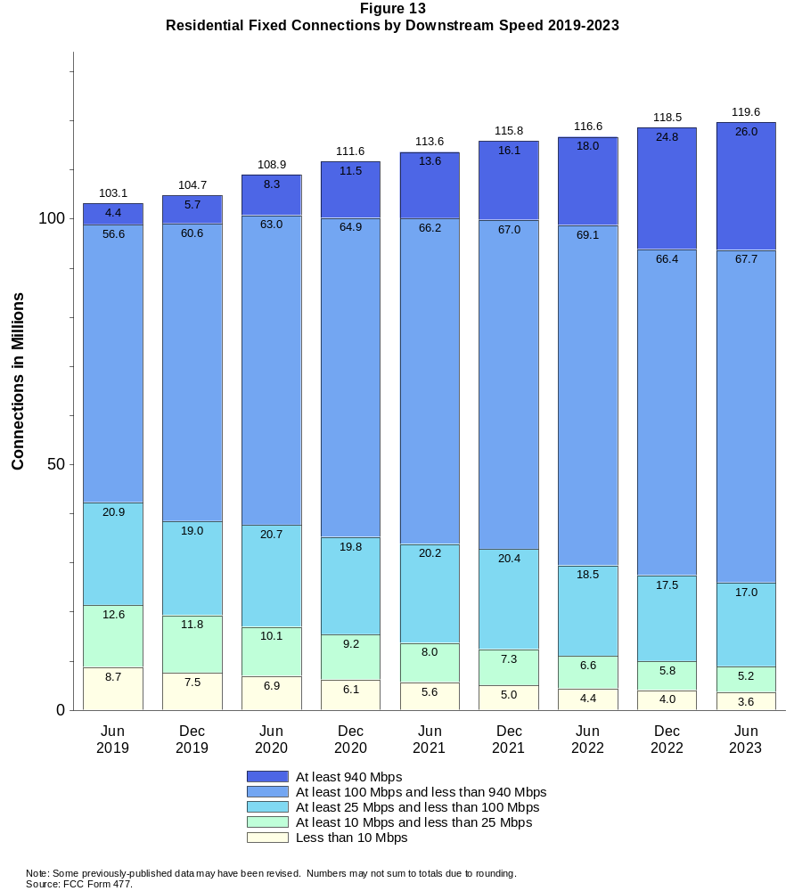

Figure 14
Distribution of Fixed Connections over 200 kbps in at Least One Direction as of June 30, 2023

 | Downstream Speed
Upstream Speed | Less than 10 Mbps | At least 10 Mbps  and less than 25 Mbps | At least 25 Mbps  and less than 100 Mbps | At least 100 Mbps  and less than 940 Mbps | At least 940 Mbps | Total
Less than 1 Mbps | 2,722 | 622 | 1 | # | # | 3,344
At least 1 Mbps & Less than 3 Mbps | 1,252 | 3,931 | 531 | 5 | 2 | 5,721
At least 3 Mbps & Less than 20 Mbps | 157 | 1,279 | 16,321 | 36,414 | 1,440 | 55,611
At least 20 Mbps & Less than 500 Mbps | 94 | 68 | 2,588 | 32,592 | 13,217 | 48,558
At least 500 Mbps | # | # | 1 | 3,973 | 12,297 | 16,272
Total | 4,226 | 5,899 | 19,440 | 72,984 | 26,956 | 129,505

Percentages

Less than 1 Mbps | 2.1 | 0.5 | 0.0 | 0.0 | 0.0 | 2.6
At least 1 Mbps & Less than 3 Mbps | 1.0 | 3.0 | 0.4 | 0.0 | 0.0 | 4.4
At least 3 Mbps & Less than 20 Mbps | 0.1 | 1.0 | 12.6 | 28.1 | 1.1 | 42.9
At least 20 Mbps & Less than 500 Mbps | 0.1 | 0.1 | 2.0 | 25.2 | 10.2 | 37.5
At least 500 Mbps | 0.0 | 0.0 | 0.0 | 3.1 | 9.5 | 12.6
Total | 3.3 | 4.6 | 15.0 | 56.4 | 20.8 | 100.0
# = Rounds to zero.
Note: Numbers may not sum to totals due to rounding.
Source: FCC Form 477.

Figure 15
Distribution of Residential Fixed Connections over 200 kbps in at Least One Direction as of June 30, 2023

 | Downstream Speed
Upstream Speed | Less than 10 Mbps | At least 10 Mbps  and less than 25 Mbps | At least 25 Mbps  and less than 100 Mbps | At least 100 Mbps  and less than 940 Mbps | At least 940 Mbps | Total
Less than 1 Mbps | 2,320 | 581 | # | # | # | 2,901
At least 1 Mbps & Less than 3 Mbps | 1,095 | 3,481 | 479 | 4 | 2 | 5,061
At least 3 Mbps & Less than 20 Mbps | 133 | 1,121 | 14,344 | 34,486 | 1,439 | 51,522
At least 20 Mbps & Less than 500 Mbps | 90 | 40 | 2,186 | 29,450 | 12,837 | 44,602
At least 500 Mbps | # | # | 1 | 3,795 | 11,745 | 15,541
Total | 3,637 | 5,224 | 17,009 | 67,734 | 26,024 | 119,627

Percentages

Less than 1 Mbps | 1.9 | 0.5 | 0.0 | 0.0 | 0.0 | 2.4
At least 1 Mbps & Less than 3 Mbps | 0.9 | 2.9 | 0.4 | 0.0 | 0.0 | 4.2
At least 3 Mbps & Less than 20 Mbps | 0.1 | 0.9 | 12.0 | 28.8 | 1.2 | 43.1
At least 20 Mbps & Less than 500 Mbps | 0.1 | 0.0 | 1.8 | 24.6 | 10.7 | 37.3
At least 500 Mbps | 0.0 | 0.0 | 0.0 | 3.2 | 9.8 | 13.0
Total | 3.0 | 4.4 | 14.2 | 56.6 | 21.8 | 100.0
# = Rounds to zero.
Note: Numbers may not sum to totals due to rounding.
Source: FCC Form 477.

Figure 16
Connections over 200 kbps in at Least One Direction by Technology 2019-2023
(in thousands)

 | 2019 |  | 2020 |  | 2021 |  | 2022 |  | 2023
Technology | Jun | Dec | Jun | Dec | Jun | Dec | Jun | Dec | Jun
Total | 459,350 | 466,320 | 480,200 | 490,890 | 500,260 | 510,200 | 518,230 | 527,297 | 535,300
Mobile | 346,600 | 352,010 | 361,740 | 369,640 | 376,840 | 384,420 | 391,876 | 399,258 | 405,795
Fixed | 112,740 | 114,310 | 118,460 | 121,250 | 123,430 | 125,780 | 126,354 | 128,038 | 129,505
Copper Wire¹ | 21,681 | 20,755 | 20,174 | 19,327 | 18,620 | 17,412 | 15,644 | 14,712 | 13,236
Coaxial Cable | 70,750 | 72,516 | 75,986 | 77,909 | 79,330 | 80,232 | 80,022 | 80,110 | 79,454
Optical Carrier | 16,748 | 17,376 | 18,459 | 19,945 | 21,120 | 23,338 | 24,984 | 26,343 | 28,310
Satellite | 1,984 | 1,975 | 1,993 | 1,931 | 1,910 | 1,873 | 2,031 | 2,039 | 2,026
Fixed Wireless | 1,580 | 1,687 | 1,853 | 2,140 | 2,445 | 2,923 | 3,672 | 4,834 | 6,480
Licensed | - | - | - | - | - | - | 1,954 | 3,213 | 4,889
Unlicensed | - | - | - | - | - | - | 1,718 | 1,621 | 1,591
¹ Power Line and Other are summarized with Copper Wire for confidentiality reasons. See Technical Notes at the end of the report for a description of FCC
Form 477 technology categories and other reporting requirements.
* = Data withheld for confidentiality reasons. # = Rounds to zero. - = Data was not collected.
Note: Some previously-published data may have been revised. Numbers may not sum to totals due to rounding.
Source: FCC Form 477.

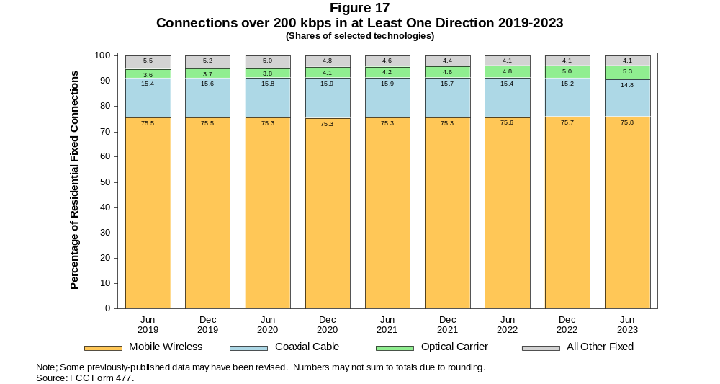

Figure 18
Residential Connections over 200 kbps in at Least One Direction by Technology 2019-2023
(in thousands)

 | 2019 |  | 2020 |  | 2021 |  | 2022 |  | 2023
Technology | Jun | Dec | Jun | Dec | Jun | Dec | Jun | Dec | Jun
Total | 383,620 | 388,360 | 403,230 | 407,650 | 415,260 | 436,580 | 442,439 | 448,601 | 454,210
Mobile | 280,490 | 283,640 | 294,300 | 296,030 | 301,680 | 320,780 | 325,832 | 330,065 | 334,582
Fixed | 103,130 | 104,720 | 108,920 | 111,620 | 113,580 | 115,790 | 116,608 | 118,536 | 119,627
Copper Wire¹ | 19,041 | 18,237 | 17,718 | 16,983 | 16,344 | 15,269 | 13,978 | 13,101 | 11,858
Coaxial Cable | 65,457 | 67,141 | 70,710 | 72,543 | 73,844 | 74,599 | 74,442 | 74,533 | 73,885
Optical Carrier | 15,410 | 16,011 | 16,986 | 18,384 | 19,414 | 21,531 | 22,941 | 24,456 | 26,255
Satellite | 1,805 | 1,795 | 1,815 | 1,752 | 1,728 | 1,692 | 1,841 | 1,949 | 1,929
Fixed Wireless | 1,421 | 1,535 | 1,694 | 1,959 | 2,251 | 2,701 | 3,406 | 4,498 | 5,701
Licensed | - | - | - | - | - | - | 1,841 | 3,022 | 4,260
Unlicensed | - | - | - | - | - | - | 1,565 | 1,476 | 1,440
¹ Power Line and Other are summarized with Copper Wire for confidentiality reasons. See Technical Notes at the end of the report for a description of FCC
Form 477 technology categories and other reporting requirements.
* = Data withheld for confidentiality reasons. # = Rounds to zero. - = Data was not collected.
Note: Some previously-published data may have been revised. Numbers may not sum to totals due to rounding.
Source: FCC Form 477.

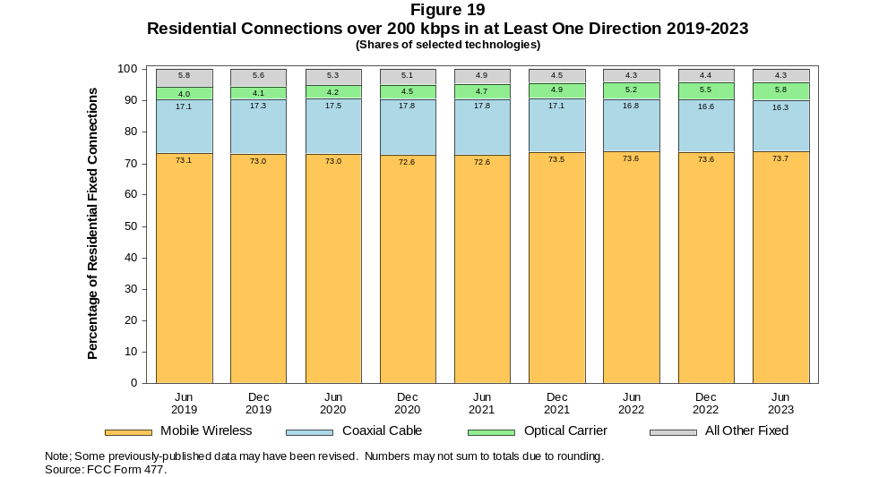

Figure 20
Fixed Connections at Least 10 Mbps Downstream and 1 Mbps Upstream by Technology 2019-2023
(in thousands)

 | 2019 |  | 2020 |  | 2021 |  | 2022 |  | 2023
Technology | Jun | Dec | Jun | Dec | Jun | Dec | Jun | Dec | Jun
Total | 100,480 | 103,610 | 109,180 | 112,450 | 115,770 | 118,770 | 120,370 | 122,664 | 124,658
Copper Wire¹ | 12,094 | 12,011 | 12,735 | 12,086 | 12,347 | 11,681 | 10,683 | 10,318 | 9,425
Coaxial Cable | 69,704 | 71,934 | 75,391 | 77,513 | 79,035 | 79,956 | 79,676 | 79,819 | 79,276
Optical Carrier | 16,078 | 16,854 | 18,008 | 19,555 | 20,813 | 23,058 | 24,820 | 26,198 | 28,182
Satellite | 1,726 | 1,737 | 1,778 | 1,727 | 1,717 | 1,700 | 1,863 | 1,935 | 1,929
Fixed Wireless | 879 | 1,078 | 1,263 | 1,564 | 1,860 | 2,379 | 3,328 | 4,396 | 5,846
Licensed | - | - | - | - | - | - | 1,907 | 3,052 | 4,601
Unlicensed | - | - | - | - | - | - | 1,421 | 1,344 | 1,245
¹ Power Line and Other are summarized with Copper Wire for confidentiality reasons. See Technical Notes at the end of the report for a description of FCC
Form 477 technology categories and other reporting requirements.
* = Data withheld for confidentiality reasons. # = Rounds to zero. - = Data was not collected.
Note: Some previously-published data may have been revised. Numbers may not sum to totals due to rounding.
Source: FCC Form 477.

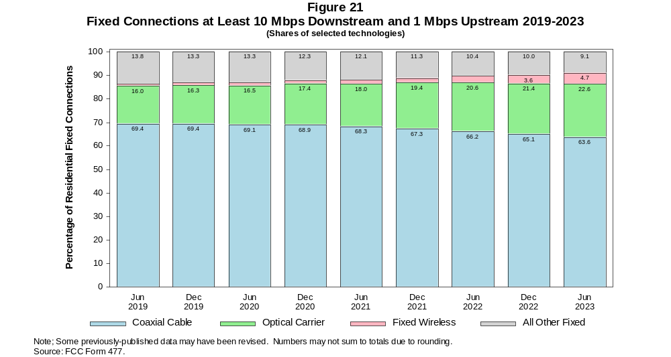

Figure 22
Residential Fixed Connections at Least 10 Mbps Downstream and 1 Mbps Upstream by Technology 2019-2023
(in thousands)

 | 2019 |  | 2020 |  | 2021 |  | 2022 |  | 2023
Technology | Jun | Dec | Jun | Dec | Jun | Dec | Jun | Dec | Jun
Total | 92,714 | 95,665 | 101,220 | 104,200 | 107,210 | 109,980 | 111,497 | 113,886 | 115,410
Copper Wire¹ | 10,871 | 10,754 | 11,440 | 10,818 | 11,066 | 10,441 | 9,652 | 9,273 | 8,532
Coaxial Cable | 64,556 | 66,691 | 70,299 | 72,215 | 73,611 | 74,386 | 74,147 | 74,295 | 73,743
Optical Carrier | 14,800 | 15,536 | 16,581 | 18,042 | 19,145 | 21,286 | 22,803 | 24,344 | 26,153
Satellite | 1,702 | 1,708 | 1,745 | 1,691 | 1,676 | 1,656 | 1,806 | 1,884 | 1,869
Fixed Wireless | 784 | 975 | 1,151 | 1,434 | 1,714 | 2,206 | 3,090 | 4,091 | 5,112
Licensed | - | - | - | - | - | - | 1,798 | 2,871 | 3,991
Unlicensed | - | - | - | - | - | - | 1,291 | 1,220 | 1,121
¹ Power Line and Other are summarized with Copper Wire for confidentiality reasons. See Technical Notes at the end of the report for a description of FCC
Form 477 technology categories and other reporting requirements.
* = Data withheld for confidentiality reasons. # = Rounds to zero. - = Data was not collected.
Note: Some previously-published data may have been revised. Numbers may not sum to totals due to rounding.
Source: FCC Form 477.

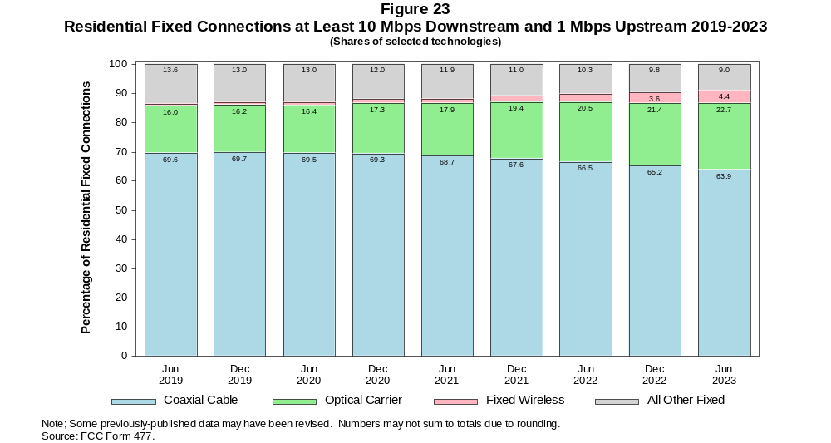

Figure 24
Fixed Connections at Least 25 Mbps Downstream and 3 Mbps Upstream by Technology 2019-2023
(in thousands)

 | 2019 |  | 2020 |  | 2021 |  | 2022 |  | 2023
Technology | Jun | Dec | Jun | Dec | Jun | Dec | Jun | Dec | Jun
Total | 86,763 | 90,490 | 97,000 | 101,630 | 106,790 | 110,630 | 113,048 | 116,189 | 118,842
Copper Wire¹ | * | * | * | * | 6,688 | 6,538 | 6,010 | 6,089 | 5,519
Coaxial Cable | 64,938 | 67,171 | 71,856 | 74,169 | 77,502 | 78,656 | 78,599 | 78,985 | 78,544
Optical Carrier | 14,902 | 15,866 | 17,091 | 18,840 | 20,171 | 22,459 | 24,282 | 25,761 | 27,894
Satellite | * | * | * | * | 1,328 | 1,353 | 1,552 | 1,685 | 1,734
Fixed Wireless | 343 | 468 | 571 | 805 | 1,105 | 1,620 | 2,605 | 3,669 | 5,152
Licensed | - | - | - | - | - | - | 1,797 | 2,801 | 4,359
Unlicensed | - | - | - | - | - | - | 808 | 868 | 793
¹ Power Line and Other are summarized with Copper Wire for confidentiality reasons. See Technical Notes at the end of the report for a description of FCC
Form 477 technology categories and other reporting requirements.
* = Data withheld for confidentiality reasons. # = Rounds to zero. - = Data was not collected.
Note: Some previously-published data may have been revised. Numbers may not sum to totals due to rounding.
Source: FCC Form 477.

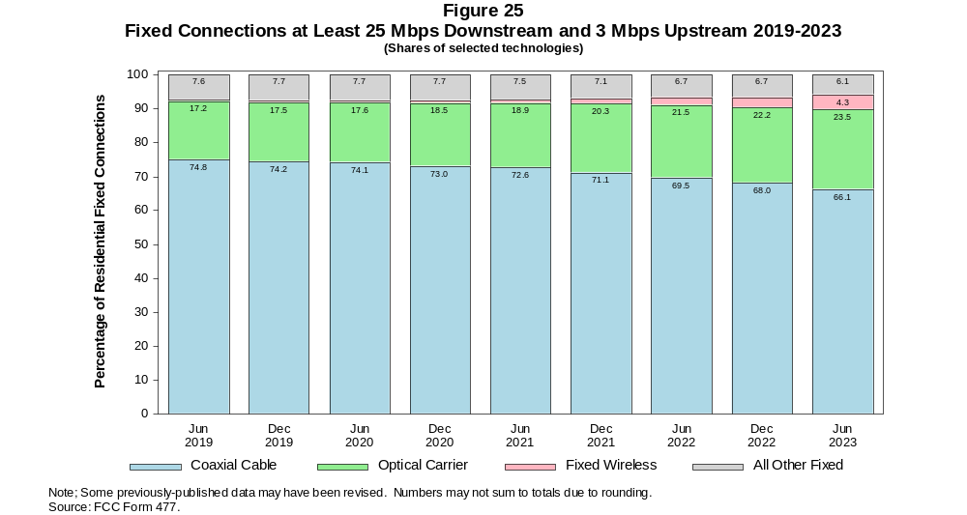

Figure 26
Residential Fixed Connections at Least 25 Mbps Downstream and 3 Mbps Upstream by Technology 2019-2023
(in thousands)

 | 2019 |  | 2020 |  | 2021 |  | 2022 |  | 2023
Technology | Jun | Dec | Jun | Dec | Jun | Dec | Jun | Dec | Jun
Total | 80,272 | 83,740 | 90,185 | 94,451 | 99,254 | 102,800 | 104,994 | 108,154 | 110,281
Copper Wire¹ | * | * | * | * | 6,068 | 5,930 | 5,511 | 5,541 | 5,104
Coaxial Cable | 60,125 | 62,231 | 67,017 | 69,098 | 72,268 | 73,262 | 73,214 | 73,556 | 73,102
Optical Carrier | 13,780 | 14,690 | 15,796 | 17,445 | 18,615 | 20,795 | 22,354 | 23,999 | 25,922
Satellite | * | * | * | * | 1,288 | 1,311 | 1,497 | 1,637 | 1,677
Fixed Wireless | 299 | 415 | 512 | 727 | 1,015 | 1,506 | 2,417 | 3,420 | 4,478
Licensed | - | - | - | - | - | - | 1,698 | 2,637 | 3,766
Unlicensed | - | - | - | - | - | - | 719 | 784 | 712
¹ Power Line and Other are summarized with Copper Wire for confidentiality reasons. See Technical Notes at the end of the report for a description of FCC
Form 477 technology categories and other reporting requirements.
* = Data withheld for confidentiality reasons. # = Rounds to zero. - = Data was not collected.
Note: Some previously-published data may have been revised. Numbers may not sum to totals due to rounding.
Source: FCC Form 477.

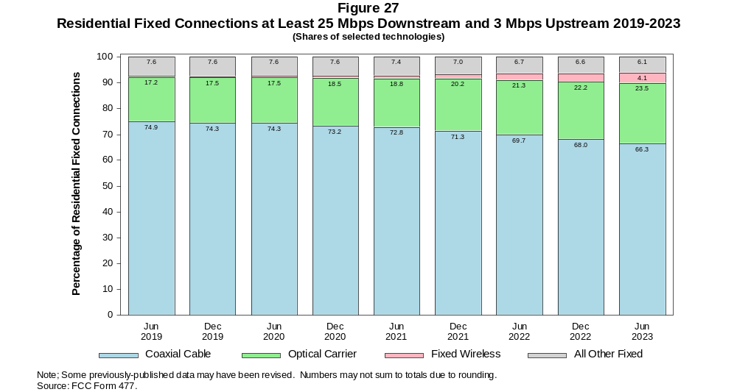

Figure 28
Fixed Connections at Least 100 Mbps Downstream and 20 Mbps Upstream by Technology 2019-2023
(in thousands)

 | 2019 |  | 2020 |  | 2021 |  | 2022 |  | 2023
Technology | Jun | Dec | Jun | Dec | Jun | Dec | Jun | Dec | Jun
Total | 22,236 | 25,621 | 29,570 | 34,493 | 38,563 | 43,352 | 52,836 | 58,395 | 62,079
Copper Wire¹ | 566 | * | * | * | * | * | * | * | *
Coaxial Cable | 11,426 | 13,088 | 15,496 | 18,420 | 20,924 | 23,298 | 29,953 | 33,391 | 34,407
Optical Carrier | 10,146 | 11,634 | 13,086 | 14,933 | 16,373 | 18,705 | 20,982 | 23,000 | 25,374
Satellite | 0 | * | * | * | * | * | * | * | *
Fixed Wireless | 97 | 119 | 116 | 143 | 180 | 239 | 500 | 880 | 1,392
Licensed | - | - | - | - | - | - | 302 | 675 | 1,209
Unlicensed | - | - | - | - | - | - | 198 | 205 | 184
¹ Power Line and Other are summarized with Copper Wire for confidentiality reasons. See Technical Notes at the end of the report for a description of FCC
Form 477 technology categories and other reporting requirements.
* = Data withheld for confidentiality reasons. # = Rounds to zero. - = Data was not collected.
Note: Some previously-published data may have been revised. Numbers may not sum to totals due to rounding.
Source: FCC Form 477.

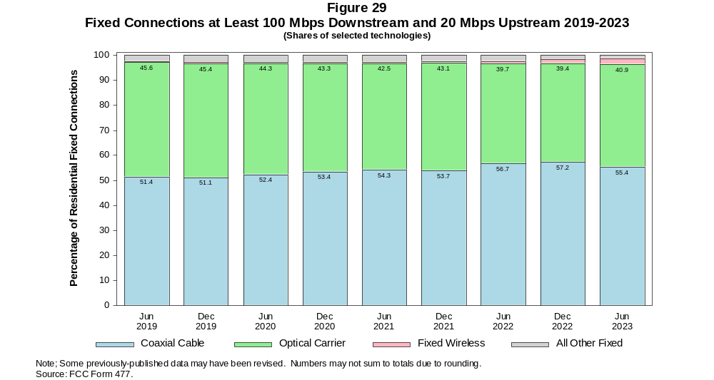

Figure 30
Residential Fixed Connections at Least 100 Mbps Downstream and 20 Mbps Upstream by Technology 2019-2023
(in thousands)

 | 2019 |  | 2020 |  | 2021 |  | 2022 |  | 2023
Technology | Jun | Dec | Jun | Dec | Jun | Dec | Jun | Dec | Jun
Total | 20,338 | 23,485 | 27,179 | 31,773 | 35,456 | 39,921 | 49,009 | 54,471 | 57,827
Copper Wire¹ | 371 | * | * | * | * | * | * | * | *
Coaxial Cable | 10,312 | 11,883 | 14,157 | 16,843 | 19,128 | 21,298 | 27,827 | 31,087 | 31,952
Optical Carrier | 9,574 | 10,952 | 12,303 | 14,055 | 15,329 | 17,537 | 19,508 | 21,672 | 23,804
Satellite | 0 | * | * | * | * | * | * | * | *
Fixed Wireless | 80 | 102 | 98 | 118 | 158 | 215 | 450 | 801 | 1,258
Licensed | - | - | - | - | - | - | 277 | 616 | 1,094
Unlicensed | - | - | - | - | - | - | 174 | 185 | 164
¹ Power Line and Other are summarized with Copper Wire for confidentiality reasons. See Technical Notes at the end of the report for a description of FCC
Form 477 technology categories and other reporting requirements.
* = Data withheld for confidentiality reasons. # = Rounds to zero. - = Data was not collected.
Note: Some previously-published data may have been revised. Numbers may not sum to totals due to rounding.
Source: FCC Form 477.

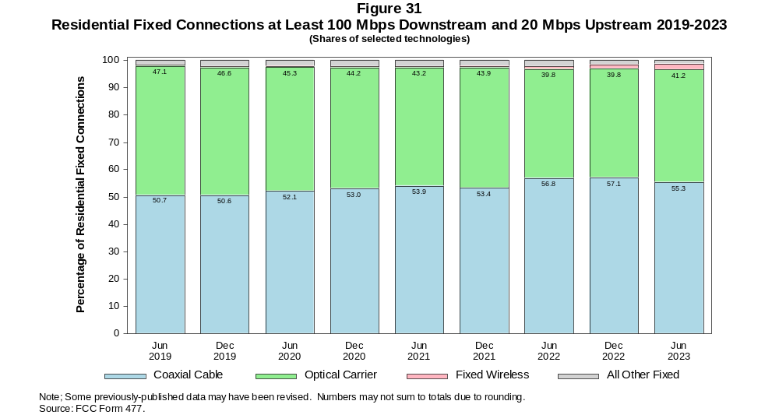

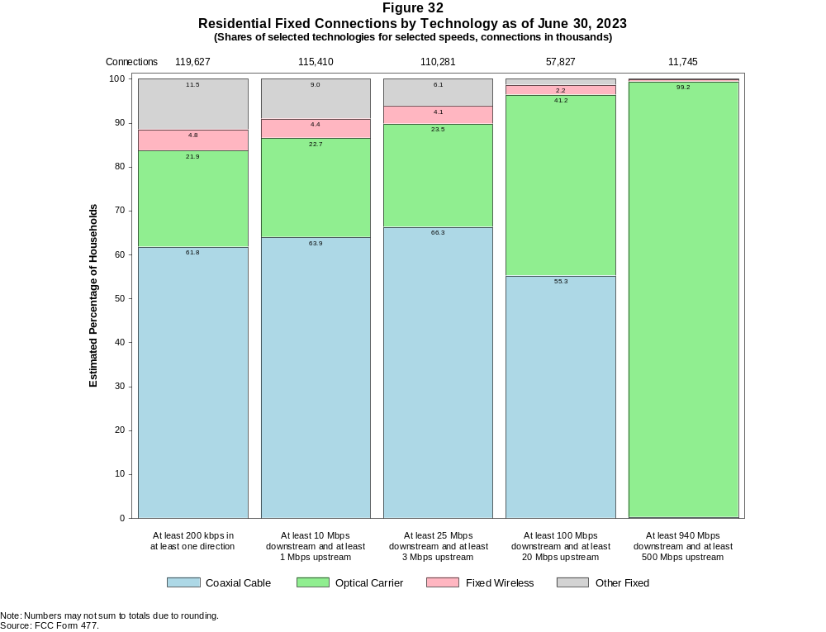

Figure 33
Fixed Connections by Downstream Speed Tier and Technology as of June 30, 2023
(in thousands)

 | Downstream Speed
Technology | Less than  10 Mbps | At least 10 Mbps  and less than  25 Mbps | At least 25 Mbps  and less than  100 Mbps | At least 100 Mbps  and less than  940 Mbps | At least  940 Mbps | Total
Total | 4,226 | 5,899 | 19,440 | 72,984 | 26,956 | 129,505
Copper Wire¹ | 3,197 | 4,065 | 4,873 | 1,076 | 26 | 13,236
Coaxial Cable | 176 | 675 | 7,427 | 56,744 | 14,432 | 79,454
Optical Carrier | 123 | 275 | 2,299 | 13,242 | 12,371 | 28,310
Satellite | * | * | * | * | 0 | 2,026
Fixed Wireless | * | * | * | * | 127 | 6,480

Percentages

Total | 3.3 | 4.6 | 15.0 | 56.4 | 20.8 | 100.0
Copper Wire¹ | 2.5 | 3.1 | 3.8 | 0.8 | 0.0 | 10.2
Coaxial Cable | 0.1 | 0.5 | 5.7 | 43.8 | 11.1 | 61.4
Optical Carrier | 0.1 | 0.2 | 1.8 | 10.2 | 9.6 | 21.9
Satellite | * | * | * | * | 0.0 | 1.6
Fixed Wireless | * | * | * | * | 0.1 | 5.0
¹ Other is summarized with Copper Wire for confidentiality reasons.
* = Data withheld for confidentiality reasons. # = Rounds to Zero.
Note: Numbers may not sum to totals due to rounding.
Source: FCC Form 477.

Figure 34
Residential Fixed Connections by Downstream Speed Tier and Technology as of June 30, 2023
(in thousands)

 | Downstream Speed
Technology | Less than  10 Mbps | At least 10 Mbps  and less than  25 Mbps | At least 25 Mbps  and less than  100 Mbps | At least 100 Mbps  and less than  940 Mbps | At least  940 Mbps | Total
Total | 3,637 | 5,224 | 17,009 | 67,734 | 26,024 | 119,627
Copper Wire¹ | 2,751 | 3,595 | 4,499 | 988 | 26 | 11,858
Coaxial Cable | 140 | 588 | 6,332 | 52,755 | 14,070 | 73,885
Optical Carrier | 97 | 218 | 1,913 | 12,218 | 11,808 | 26,255
Satellite | * | * | 1,068 | * | 0 | 1,929
Fixed Wireless | * | * | 3,197 | * | 121 | 5,701

Percentages

Total | 3.0 | 4.4 | 14.2 | 56.6 | 21.8 | 100.0
Copper Wire¹ | 2.3 | 3.0 | 3.8 | 0.8 | 0.0 | 9.9
Coaxial Cable | 0.1 | 0.5 | 5.3 | 44.1 | 11.8 | 61.8
Optical Carrier | 0.1 | 0.2 | 1.6 | 10.2 | 9.9 | 21.9
Satellite | * | * | 0.9 | * | 0.0 | 1.6
Fixed Wireless | * | * | 2.7 | * | 0.1 | 4.8
¹ Other is summarized with Copper Wire for confidentiality reasons.
* = Data withheld for confidentiality reasons. # = Rounds to Zero.
Note: Numbers may not sum to totals due to rounding.
Source: FCC Form 477.

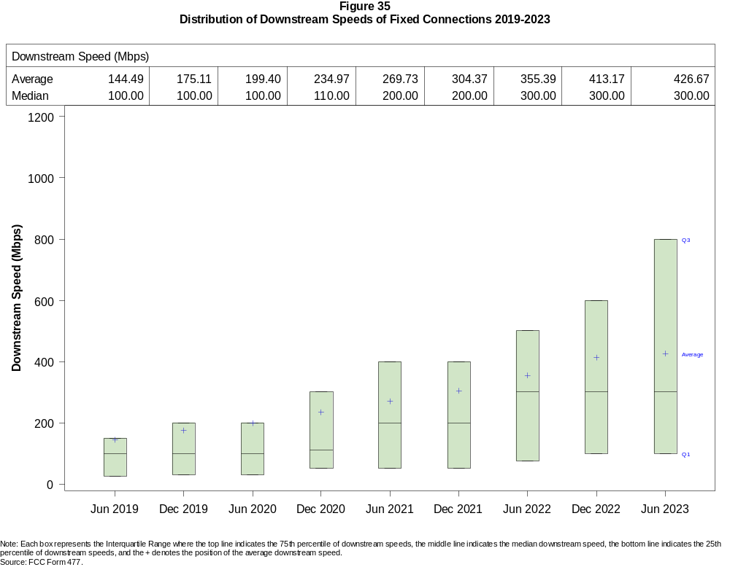

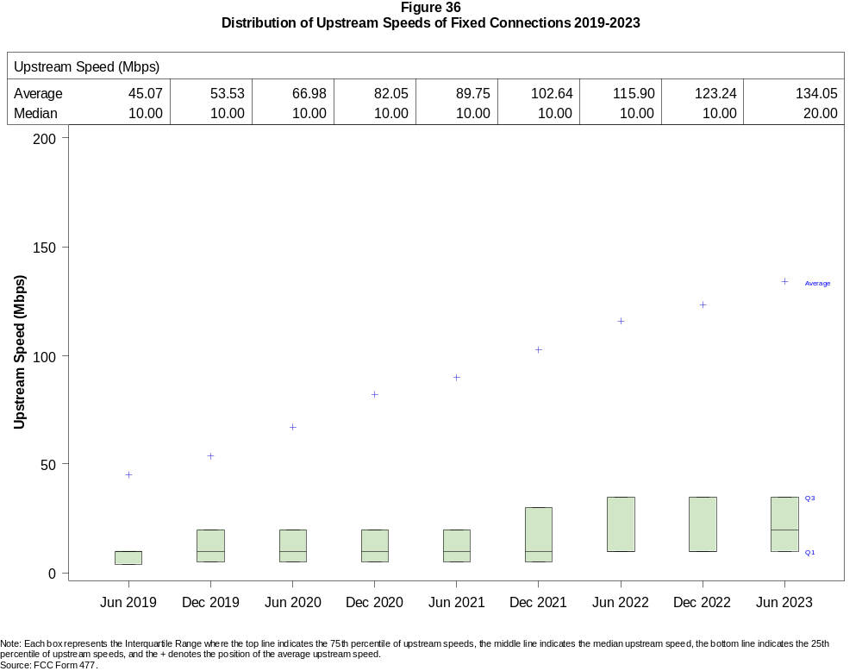

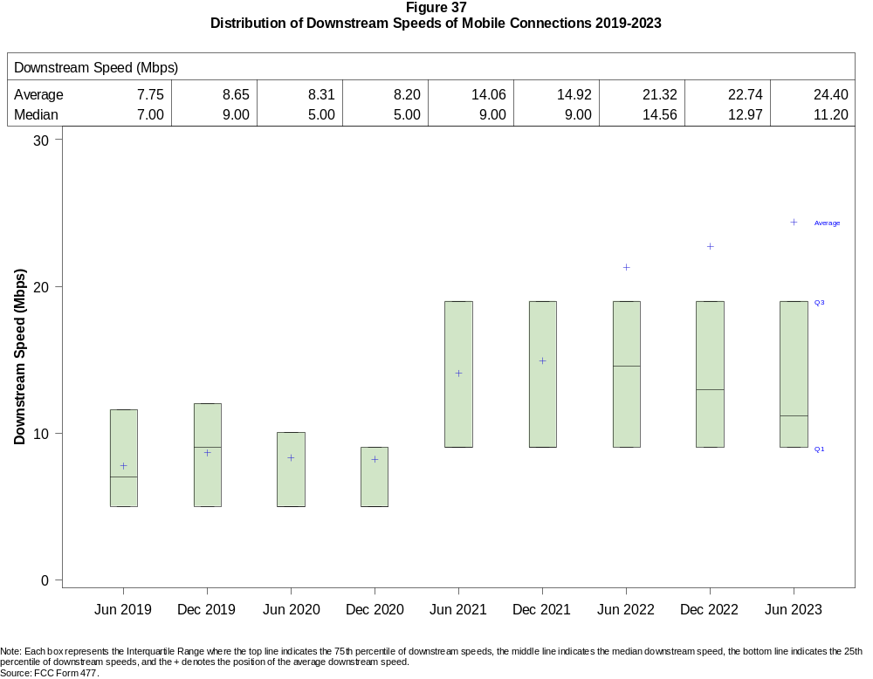

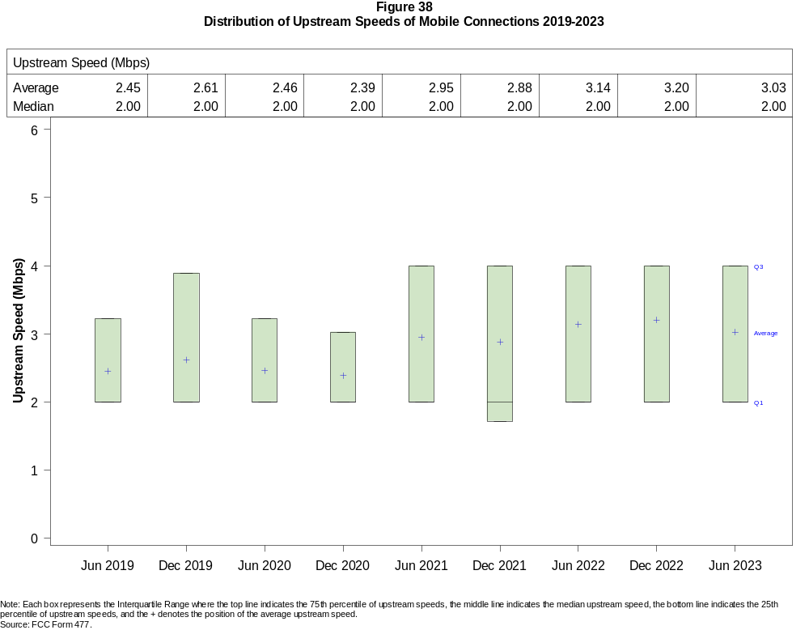

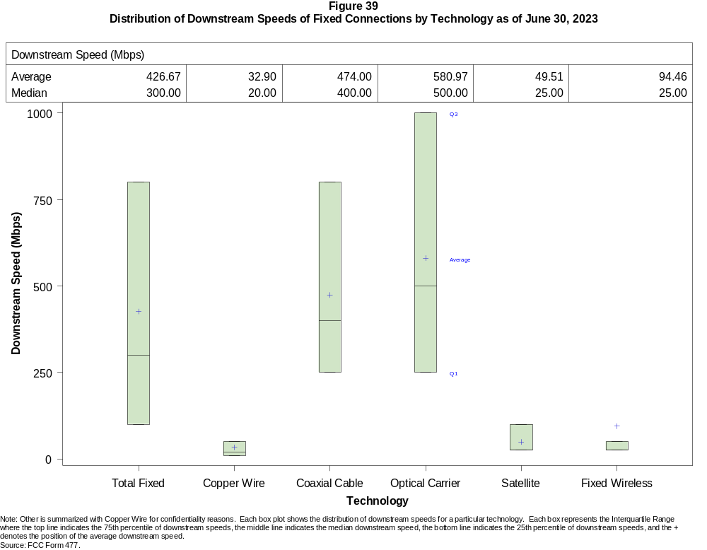

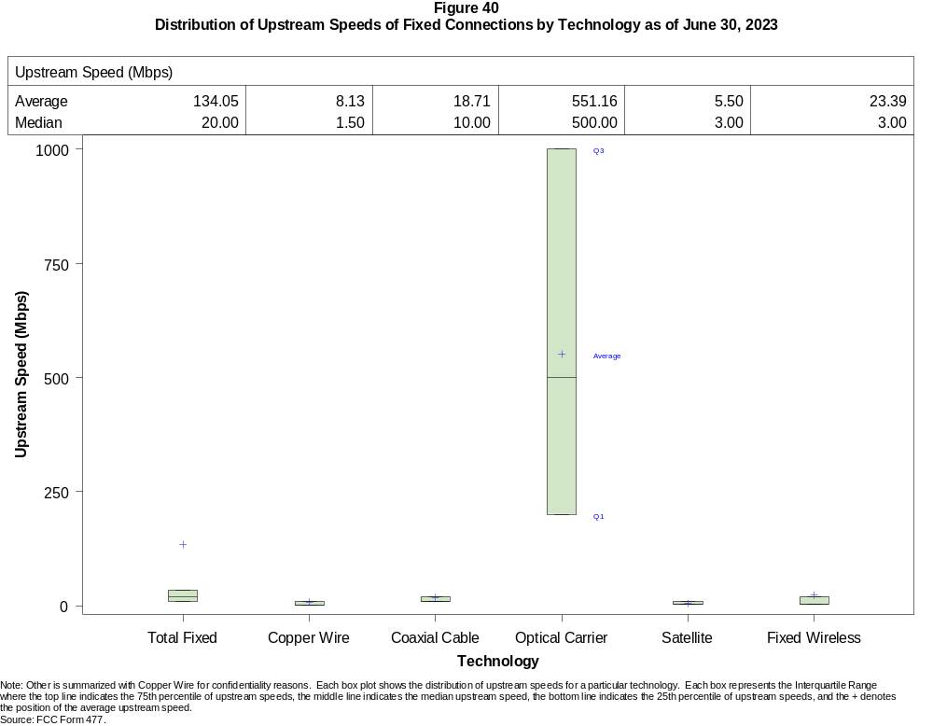

Figure 41
Nationwide Number of Providers of Connections over 200 kbps in at Least One Direction
by Technology 2019-2023

 | 2019 |  | 2020 |  | 2021 |  | 2022 |  | 2023
Technology | Jun | Dec | Jun | Dec | Jun | Dec | Jun | Dec | Jun
Total | 2,224 | 2,248 | 2,281 | 2,382 | 2,392 | 2,384 | 2,252 | 2,282 | 2,235
Mobile | 70 | 67 | 64 | 64 | 63 | 62 | 58 | 57 | 56
Fixed | 2,203 | 2,230 | 2,266 | 2,371 | 2,378 | 2,371 | 2,243 | 2,273 | 2,226
Copper Wire¹ | 827 | 803 | 797 | 773 | 755 | 743 | 594 | 570 | 546
Coaxial Cable | 381 | 373 | 365 | 368 | 362 | 352 | 311 | 305 | 309
Optical Carrier | 1,310 | 1,331 | 1,380 | 1,442 | 1,477 | 1,505 | 1,475 | 1,519 | 1,539
Satellite | 5 | 5 | 5 | 6 | 6 | 5 | 4 | 4 | 4
Fixed Wireless | 1,249 | 1,281 | 1,313 | 1,397 | 1,383 | 1,359 | 1,237 | 1,247 | 1,190
Licensed | - | - | - | - | - | - | 299 | 357 | 375
Unlicensed | - | - | - | - | - | - | 1,133 | 1,135 | 1,076
¹ Prior to June 2022, Power Line is summarized with Other for confidentiality reasons.
* = 1 - 3 providers. - = Data not collected.
Note: Multiple FCC Form 477 filers within a holding company structure count as one provider. Some previously-published data may have been revised.
Source: FCC Form 477.

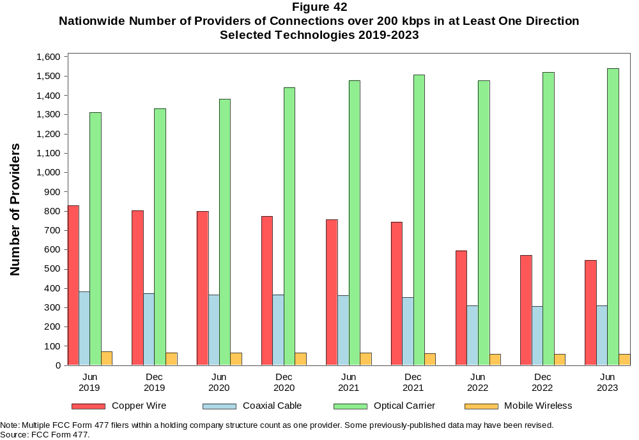

Figure 43
Residential Fixed Connections and Households by State as of June 30, 2023
(Connections and households in thousands)

 |  | At least 200 kbps in  at least One Direction |  | At least 10 Mbps Down  and 1 Mbps Up |  | At least 25 Mbps Down  and 3 Mbps Up |  | At least 100 Mbps Down  and 20 Mbps Up |  | At least 940 Mbps Down  and 500 Mbps Up
State | Households | Connections | Subscribership  Ratio | Connections | Subscribership  Ratio | Connections | Subscribership  Ratio | Connections | Subscribership  Ratio | Connections | Subscribership  Ratio
Alabama | 1,933 | 1,715 | 0.89 | 1,613 | 0.83 | 1,514 | 0.78 | 783 | 0.40 | 180 | 0.09
Alaska | 264 | 244 | 0.92 | 234 | 0.88 | 197 | 0.74 | * | * | * | *
American Samoa | 10 | * | * | * | * | * | * | 0 | 0.00 | 0 | 0.00
Arizona | 2,739 | 2,584 | 0.94 | 2,461 | 0.90 | 2,326 | 0.85 | 786 | 0.29 | 106 | 0.04
Arkansas | 1,172 | 1,005 | 0.86 | 927 | 0.79 | 842 | 0.72 | 473 | 0.40 | 87 | 0.07
California | 13,316 | 12,975 | 0.97 | 12,670 | 0.95 | 12,169 | 0.91 | 5,646 | 0.42 | 837 | 0.06
Colorado | 2,278 | 2,311 | 1.01 | 2,217 | 0.97 | 2,114 | 0.93 | 903 | 0.40 | 176 | 0.08
Connecticut | 1,410 | 1,301 | 0.92 | 1,282 | 0.91 | 1,244 | 0.88 | 750 | 0.53 | 87 | 0.06
Delaware | 389 | 412 | 1.06 | 411 | 1.06 | 410 | 1.05 | 270 | 0.69 | * | *
District of Columbia | 316 | 283 | 0.89 | 279 | 0.88 | 278 | 0.88 | 182 | 0.58 | * | *
Florida | 8,353 | 8,704 | 1.04 | 8,498 | 1.02 | 8,265 | 0.99 | 4,180 | 0.50 | 694 | 0.08
Georgia | 3,946 | 3,753 | 0.95 | 3,614 | 0.92 | 3,448 | 0.87 | 1,995 | 0.51 | 491 | 0.12
Guam | 42 | 36 | 0.85 | 34 | 0.80 | * | * | * | * | 0 | 0.00
Hawaii | 484 | 499 | 1.03 | 491 | 1.01 | 477 | 0.99 | * | * | * | *
Idaho | 675 | 631 | 0.93 | 576 | 0.85 | 500 | 0.74 | 313 | 0.46 | 42 | 0.06
Illinois | 4,969 | 4,373 | 0.88 | 4,222 | 0.85 | 3,996 | 0.80 | 1,982 | 0.40 | 198 | 0.04
Indiana | 2,654 | 2,401 | 0.90 | 2,281 | 0.86 | 2,139 | 0.81 | 1,123 | 0.42 | 209 | 0.08
Iowa | 1,290 | 1,116 | 0.86 | 1,045 | 0.81 | 953 | 0.74 | 655 | 0.51 | 87 | 0.07
Kansas | 1,149 | 1,027 | 0.89 | 985 | 0.86 | 925 | 0.80 | 488 | 0.42 | 165 | 0.14
Kentucky | 1,769 | 1,595 | 0.90 | 1,508 | 0.85 | 1,409 | 0.80 | 757 | 0.43 | 142 | 0.08
Louisiana | 1,765 | 1,502 | 0.85 | 1,416 | 0.80 | 1,321 | 0.75 | 587 | 0.33 | 121 | 0.07
Maine | 580 | 597 | 1.03 | 565 | 0.97 | 504 | 0.87 | 129 | 0.22 | 3 | 0.01
Maryland | 2,318 | 2,248 | 0.97 | 2,215 | 0.96 | 2,194 | 0.95 | 1,475 | 0.64 | * | *
Massachusetts | 2,741 | 2,673 | 0.98 | 2,635 | 0.96 | 2,623 | 0.96 | 1,530 | 0.56 | 322 | 0.12
Michigan | 4,009 | 3,697 | 0.92 | 3,564 | 0.89 | 3,401 | 0.85 | 1,371 | 0.34 | 101 | 0.03
Minnesota | 2,256 | 2,107 | 0.93 | 2,019 | 0.89 | 1,881 | 0.83 | 812 | 0.36 | 98 | 0.04
Mississippi | 1,121 | 903 | 0.81 | 830 | 0.74 | 732 | 0.65 | 485 | 0.43 | 168 | 0.15
Missouri | 2,458 | 2,153 | 0.88 | 2,017 | 0.82 | 1,856 | 0.75 | 1,034 | 0.42 | 255 | 0.10
Montana | 444 | 426 | 0.96 | 398 | 0.90 | 354 | 0.80 | 106 | 0.24 | 11 | 0.02
Nebraska | 776 | 700 | 0.90 | 669 | 0.86 | 632 | 0.81 | 297 | 0.38 | 52 | 0.07

Figure 43 - Continued
Residential Fixed Connections and Households by State as of June 30, 2023
(Connections and households in thousands)

 |  | At least 200 kbps in  at least One Direction |  | At least 10 Mbps Down  and 1 Mbps Up |  | At least 25 Mbps Down  and 3 Mbps Up |  | At least 100 Mbps Down  and 20 Mbps Up |  | At least 940 Mbps Down  and 500 Mbps Up
State | Households | Connections | Subscribership  Ratio | Connections | Subscribership  Ratio | Connections | Subscribership  Ratio | Connections | Subscribership  Ratio | Connections | Subscribership  Ratio
Nevada | 1,164 | 1,129 | 0.97 | 1,092 | 0.94 | 1,051 | 0.90 | 374 | 0.32 | 61 | 0.05
New Hampshire | 545 | 549 | 1.01 | 535 | 0.98 | 515 | 0.94 | 288 | 0.53 | 5 | 0.01
New Jersey | 3,438 | 3,207 | 0.93 | 3,171 | 0.92 | 3,153 | 0.92 | 2,372 | 0.69 | * | *
New Mexico | 813 | 722 | 0.89 | 668 | 0.82 | 603 | 0.74 | 196 | 0.24 | 24 | 0.03
New York | 7,605 | 6,937 | 0.91 | 6,867 | 0.90 | 6,702 | 0.88 | 4,198 | 0.55 | 1,063 | 0.14
North Carolina | 4,105 | 4,207 | 1.02 | 3,980 | 0.97 | 3,824 | 0.93 | 1,935 | 0.47 | 404 | 0.10
North Dakota | 320 | 295 | 0.92 | 290 | 0.91 | 285 | 0.89 | 261 | 0.82 | 13 | 0.04
Northern Mariana Isl | 16 | * | * | * | * | * | * | 0 | 0.00 | 0 | 0.00
Ohio | 4,789 | 4,384 | 0.92 | 4,221 | 0.88 | 3,986 | 0.83 | 1,760 | 0.37 | 173 | 0.04
Oklahoma | 1,523 | 1,305 | 0.86 | 1,225 | 0.80 | 1,128 | 0.74 | 585 | 0.38 | 155 | 0.10
Oregon | 1,681 | 1,585 | 0.94 | 1,525 | 0.91 | 1,458 | 0.87 | 575 | 0.34 | 96 | 0.06
Pennsylvania | 5,194 | 4,761 | 0.92 | 4,567 | 0.88 | 4,499 | 0.87 | 2,729 | 0.53 | * | *
Puerto Rico | 1,220 | 770 | 0.63 | 712 | 0.58 | 604 | 0.50 | 231 | 0.19 | 11 | 0.01
Rhode Island | 432 | 413 | 0.95 | 411 | 0.95 | 410 | 0.95 | 219 | 0.51 | * | *
South Carolina | 2,023 | 2,007 | 0.99 | 1,943 | 0.96 | 1,850 | 0.91 | 994 | 0.49 | 136 | 0.07
South Dakota | 351 | 328 | 0.93 | 323 | 0.92 | 315 | 0.90 | 254 | 0.72 | 15 | 0.04
Tennessee | 2,714 | 2,534 | 0.93 | 2,455 | 0.90 | 2,363 | 0.87 | 1,351 | 0.50 | 398 | 0.15
Texas | 10,491 | 10,107 | 0.96 | 9,815 | 0.94 | 9,364 | 0.89 | 5,543 | 0.53 | 1,432 | 0.14
Utah | 1,063 | 1,039 | 0.98 | 1,002 | 0.94 | 959 | 0.90 | 515 | 0.48 | 181 | 0.17
Vermont | 266 | 278 | 1.05 | 257 | 0.97 | 224 | 0.84 | 107 | 0.40 | 16 | 0.06
Virgin Islands | 43 | * | * | * | * | * | * | * | * | * | *
Virginia | 3,290 | 3,053 | 0.93 | 2,936 | 0.89 | 2,885 | 0.88 | 1,710 | 0.52 | 633 | 0.19
Washington | 2,979 | 2,955 | 0.99 | 2,838 | 0.95 | 2,716 | 0.91 | 1,108 | 0.37 | 200 | 0.07
West Virginia | 716 | 579 | 0.81 | 529 | 0.74 | 477 | 0.67 | 274 | 0.38 | 23 | 0.03
Wisconsin | 2,425 | 2,249 | 0.93 | 2,123 | 0.88 | 1,946 | 0.80 | 702 | 0.29 | 65 | 0.03
Wyoming | 234 | 225 | 0.96 | 212 | 0.91 | 199 | 0.85 | 59 | 0.25 | 6 | 0.02
Total | 127,067 | 119,627 | 0.94 | 115,410 | 0.91 | 110,281 | 0.87 | 57,827 | 0.46 | 11,745 | 0.09
# = Rounds to Zero; * = Data withheld for confidentiality reasons.
Note: Numbers may not sum to totals due to rounding.
Sources: FCC Form 477 (Connections); 2018-2022 ACS 5-year estimates; Census 2010.

Figure 44
Connections by Type of End User by State as of June 30, 2023
(Connections in thousands)

 | Connections |  | Percentages
State | Residential | Business | Residential | Business | Total
Alabama | 6,642 | 1,090 | 85.9 | 14.1 | 7,733
Alaska | 938 | 156 | 85.7 | 14.3 | 1,094
American Samoa | * | * | * | * | *
Arizona | 9,746 | 1,469 | 86.9 | 13.1 | 11,215
Arkansas | 3,944 | 540 | 88.0 | 12.0 | 4,484
California | 54,361 | 9,940 | 84.5 | 15.5 | 64,301
Colorado | 7,757 | 1,559 | 83.3 | 16.7 | 9,316
Connecticut | 4,998 | 932 | 84.3 | 15.7 | 5,930
Delaware | 1,431 | 249 | 85.2 | 14.8 | 1,680
District of Columbia | 1,209 | 693 | 63.5 | 36.5 | 1,902
Florida | 32,344 | 5,418 | 85.7 | 14.3 | 37,762
Georgia | 14,877 | 2,592 | 85.2 | 14.8 | 17,468
Guam | 172 | 43 | 79.9 | 20.1 | 216
Hawaii | 1,928 | 378 | 83.6 | 16.4 | 2,306
Idaho | 2,349 | 358 | 86.8 | 13.2 | 2,706
Illinois | 17,133 | 3,219 | 84.2 | 15.8 | 20,352
Indiana | 8,686 | 1,366 | 86.4 | 13.6 | 10,052
Iowa | 4,046 | 653 | 86.1 | 13.9 | 4,699
Kansas | 3,805 | 602 | 86.3 | 13.7 | 4,406
Kentucky | 5,771 | 961 | 85.7 | 14.3 | 6,732
Louisiana | 6,355 | 903 | 87.6 | 12.4 | 7,258
Maine | 1,771 | 375 | 82.5 | 17.5 | 2,146
Maryland | 8,607 | 1,452 | 85.6 | 14.4 | 10,060
Massachusetts | 9,521 | 1,885 | 83.5 | 16.5 | 11,406
Michigan | 13,141 | 2,403 | 84.5 | 15.5 | 15,544
Minnesota | 7,390 | 1,338 | 84.7 | 15.3 | 8,728
Mississippi | 3,958 | 523 | 88.3 | 11.7 | 4,481
Missouri | 7,952 | 1,441 | 84.7 | 15.3 | 9,393
Montana | 1,393 | 268 | 83.9 | 16.1 | 1,661
Nebraska | 2,486 | 512 | 82.9 | 17.1 | 2,999
Nevada | 4,427 | 610 | 87.9 | 12.1 | 5,036
New Hampshire | 1,788 | 404 | 81.6 | 18.4 | 2,192
New Jersey | 13,029 | 2,414 | 84.4 | 15.6 | 15,443
New Mexico | 2,810 | 428 | 86.8 | 13.2 | 3,239
New York | 28,027 | 5,861 | 82.7 | 17.3 | 33,888
North Carolina | 14,140 | 2,668 | 84.1 | 15.9 | 16,808
North Dakota | 1,024 | 170 | 85.8 | 14.2 | 1,194
Northern Mariana Isl | * | * | * | * | *
Ohio | 15,467 | 2,953 | 84.0 | 16.0 | 18,420
Oklahoma | 5,199 | 800 | 86.7 | 13.3 | 5,999
Oregon | 5,494 | 1,087 | 83.5 | 16.5 | 6,581
Pennsylvania | 17,422 | 3,125 | 84.8 | 15.2 | 20,546
Puerto Rico | 3,270 | 291 | 91.8 | 8.2 | 3,560
Rhode Island | 1,501 | 282 | 84.2 | 15.8 | 1,782
South Carolina | 6,847 | 1,131 | 85.8 | 14.2 | 7,978
South Dakota | 1,148 | 172 | 86.9 | 13.1 | 1,321
Tennessee | 9,376 | 1,568 | 85.7 | 14.3 | 10,944
Texas | 41,697 | 6,808 | 86.0 | 14.0 | 48,505
Utah | 3,950 | 843 | 82.4 | 17.6 | 4,793
Vermont | 795 | 212 | 78.9 | 21.1 | 1,008
Virgin Islands | 46 | 13 | 77.8 | 22.2 | 59
Virginia | 11,622 | 2,107 | 84.7 | 15.3 | 13,728
Washington | 10,286 | 1,997 | 83.7 | 16.3 | 12,282
West Virginia | 2,180 | 276 | 88.8 | 11.2 | 2,456
Wisconsin | 7,073 | 1,386 | 83.6 | 16.4 | 8,459
Wyoming | 775 | 144 | 84.3 | 15.7 | 919
Total | 454,210 | 81,091 | 84.9 | 15.1 | 535,300
* = Data withheld for confidentiality reasons. # = Rounds to Zero.
Note: Numbers may not sum to totals due to rounding.
Source: FCC Form 477.

Figure 45
Connections by Technology by State as of June 30, 2023
(Connections in thousands)

State | Copper  Wire¹ | Coaxial  Cable | Optical  Carrier | Other  Fixed² | Mobile  Wireless | Total
Alabama | 285 | 990 | 440 | 147 | 5,871 | 7,733
Alaska | 63 | * | 19 | * | 812 | 1,094
American Samoa | 0 | * | * | * | * | *
Arizona | 409 | 1,826 | 224 | 296 | 8,461 | 11,215
Arkansas | 231 | 460 | 304 | 96 | 3,392 | 4,484
California | 1,610 | 9,575 | 2,017 | 877 | 50,221 | 64,301
Colorado | * | 1,671 | 296 | * | 6,840 | 9,316
Connecticut | * | 1,110 | 200 | * | 4,522 | 5,930
Delaware | * | * | * | 19 | 1,238 | 1,680
District of Columbia | * | * | * | 16 | 1,592 | 1,902
Florida | 806 | 6,289 | 1,909 | 393 | 28,366 | 37,762
Georgia | 578 | 2,284 | 1,014 | 206 | 13,387 | 17,468
Guam | * | * | 1 | * | * | 216
Hawaii | * | * | * | 12 | 1,755 | 2,306
Idaho | 152 | 294 | 107 | 130 | 2,024 | 2,706
Illinois | 663 | 3,167 | 509 | 387 | 15,626 | 20,352
Indiana | 355 | 1,417 | 603 | 211 | 7,467 | 10,052
Iowa | 195 | 459 | 426 | 133 | 3,486 | 4,699
Kansas | 125 | 506 | 371 | 114 | 3,291 | 4,406
Kentucky | 242 | 889 | 495 | 98 | 5,007 | 6,732
Louisiana | 257 | 914 | 335 | 127 | 5,625 | 7,258
Maine | 85 | 501 | 59 | 34 | 1,466 | 2,146
Maryland | * | 1,343 | * | 91 | 7,653 | 10,060
Massachusetts | * | 2,147 | 618 | * | 8,523 | 11,406
Michigan | 495 | 2,866 | 329 | 287 | 11,567 | 15,544
Minnesota | 334 | 1,367 | 378 | 192 | 6,457 | 8,728
Mississippi | 238 | 376 | 335 | 79 | 3,453 | 4,481
Missouri | 403 | 1,101 | 610 | 221 | 7,057 | 9,393
Montana | 71 | * | 64 | * | 1,188 | 1,661
Nebraska | 90 | 382 | 220 | 71 | 2,236 | 2,999

Figure 45 - Continued
Connections by Technology by State as of June 30, 2023
(Connections in thousands)

State | Copper  Wire¹ | Coaxial  Cable | Optical  Carrier | Other  Fixed² | Mobile  Wireless | Total
Nevada | 111 | 859 | 135 | 110 | 3,822 | 5,036
New Hampshire | 38 | * | 77 | * | 1,553 | 2,192
New Jersey | 47 | 2,015 | 1,327 | 96 | 11,959 | 15,443
New Mexico | 172 | 458 | 70 | 78 | 2,461 | 3,239
New York | 115 | 4,776 | 2,442 | 219 | 26,336 | 33,888
North Carolina | 455 | 2,875 | 955 | 239 | 12,284 | 16,808
North Dakota | 12 | 172 | 134 | 10 | 865 | 1,194
Northern Mariana Isl | * | * | * | 0 | * | *
Ohio | 544 | 3,164 | 714 | 304 | 13,695 | 18,420
Oklahoma | 232 | 630 | 384 | 173 | 4,580 | 5,999
Oregon | 150 | 1,164 | 272 | 135 | 4,859 | 6,581
Pennsylvania | 272 | 3,413 | 1,212 | 224 | 15,425 | 20,546
Puerto Rico | * | * | 172 | 93 | * | 3,560
Rhode Island | * | * | * | 11 | 1,338 | 1,782
South Carolina | 236 | 1,275 | 535 | 122 | 5,810 | 7,978
South Dakota | 25 | 201 | 116 | 20 | 959 | 1,321
Tennessee | 265 | 1,444 | 882 | 156 | 8,198 | 10,944
Texas | 1,098 | 5,696 | 3,200 | 953 | 37,557 | 48,505
Utah | 105 | 582 | 304 | 121 | 3,681 | 4,793
Vermont | 60 | 182 | 67 | 16 | 683 | 1,008
Virgin Islands | 0 | * | * | * | * | 59
Virginia | 151 | 1,763 | 1,171 | 196 | 10,448 | 13,728
Washington | 310 | 2,251 | 348 | 241 | 9,133 | 12,282
West Virginia | * | 417 | 54 | * | 1,831 | 2,456
Wisconsin | 393 | * | 384 | * | 6,021 | 8,459
Wyoming | 34 | 134 | 25 | 57 | 668 | 919
Total | 13,236 | 79,454 | 28,310 | 8,506 | 405,795 | 535,300
* = Data withheld for confidentiality reasons. # = Rounds to Zero.
¹ Other is summarized with Copper Wire for confidentiality reasons.
² Fixed Wireless and Satellite are summarized as Other Fixed for confidentiality reasons.
Note: Numbers may not sum to totals due to rounding.
Source: FCC Form 477.

Figure 46
Percentage of Fixed Connections by Downstream Speed by State as of June 30, 2023

 | Over 200 kbps Upstream and
State | % over 200 kbps  Downstream | % at least 10 Mbps  Downstream | % at least 25 Mbps  Downstream | % at least 100 Mbps  Downstream | % at least 940 Mbps  Downstream
Alabama | 99.6 | 95.0 | 88.5 | 71.9 | 16.2
Alaska | 99.9 | 94.8 | 80.9 | * | *
American Samoa | * | * | * | * | *
Arizona | 99.5 | 95.8 | 90.5 | 75.5 | 16.5
Arkansas | 99.6 | 93.7 | 84.1 | 64.7 | 15.6
California | 99.9 | 97.4 | 93.2 | 79.1 | 19.2
Colorado | 99.6 | 96.5 | 91.6 | 75.6 | 29.8
Connecticut | 99.8 | 98.4 | 95.8 | 87.3 | 23.7
Delaware | 99.9 | 99.5 | 99.2 | 86.3 | 38.3
District of Columbia | 99.8 | 97.7 | 97.0 | 85.5 | 29.5
Florida | 99.7 | 98.0 | 95.1 | 78.9 | 17.4
Georgia | 99.7 | 96.2 | 91.8 | 73.7 | 24.9
Guam | 100.0 | 89.7 | 80.1 | 8.6 | *
Hawaii | 99.9 | 97.5 | 94.5 | * | *
Idaho | 99.1 | 92.8 | 80.7 | 59.8 | 14.1
Illinois | 99.9 | 96.5 | 91.3 | 68.6 | 19.3
Indiana | 99.7 | 95.6 | 89.2 | 68.2 | 18.4
Iowa | 99.8 | 94.8 | 86.3 | 64.3 | 23.4
Kansas | 99.7 | 96.5 | 89.9 | 73.0 | 23.8
Kentucky | 99.8 | 94.7 | 89.0 | 74.1 | 12.5
Louisiana | 99.6 | 94.8 | 87.9 | 71.9 | 16.2
Maine | 99.5 | 93.2 | 85.1 | 73.3 | 6.9
Maryland | 99.8 | 98.2 | 97.1 | 84.0 | 37.6
Massachusetts | 99.9 | 98.3 | 97.8 | 88.2 | 31.2
Michigan | 99.8 | 96.5 | 91.9 | 72.4 | 14.1
Minnesota | 99.7 | 96.5 | 90.3 | 70.5 | 21.8
Mississippi | 99.5 | 92.3 | 81.8 | 62.9 | 29.1
Missouri | 99.7 | 95.4 | 86.8 | 69.6 | 18.0
Montana | 99.6 | 94.9 | 84.2 | 66.9 | 4.7
Nebraska | 99.9 | 96.1 | 90.6 | 76.1 | 12.9

Figure 46 - Continued
Percentage of Fixed Connections by Downstream Speed by State as of June 30, 2023

 | Over 200 kbps Upstream and
State | % over 200 kbps  Downstream | % at least 10 Mbps  Downstream | % at least 25 Mbps  Downstream | % at least 100 Mbps  Downstream | % at least 940 Mbps  Downstream
Nevada | 99.6 | 97.2 | 93.7 | 81.9 | 17.6
New Hampshire | 99.7 | 96.3 | 93.5 | 83.9 | 25.6
New Jersey | 99.8 | 98.8 | 98.0 | 89.7 | 34.9
New Mexico | 99.5 | 94.2 | 84.5 | 60.2 | 16.9
New York | 99.9 | 98.8 | 96.4 | 89.4 | 19.4
North Carolina | 99.6 | 96.1 | 91.2 | 80.2 | 13.6
North Dakota | 99.8 | 98.7 | 96.8 | 89.7 | 52.2
Northern Mariana Isl | * | * | * | * | *
Ohio | 99.8 | 96.6 | 90.9 | 76.8 | 10.7
Oklahoma | 99.6 | 93.9 | 86.1 | 70.4 | 19.6
Oregon | 99.8 | 97.0 | 92.3 | 75.8 | 23.1
Pennsylvania | 99.7 | 96.4 | 94.4 | 80.8 | 27.3
Puerto Rico | 100.0 | 91.8 | 79.1 | 34.3 | 2.3
Rhode Island | 99.7 | 99.1 | 98.8 | 92.2 | 32.8
South Carolina | 99.8 | 97.1 | 92.2 | 78.8 | 11.6
South Dakota | 99.8 | 98.5 | 96.1 | 80.4 | 49.6
Tennessee | 99.8 | 97.0 | 93.1 | 76.3 | 23.7
Texas | 99.7 | 97.2 | 92.5 | 77.0 | 22.4
Utah | 99.8 | 96.8 | 92.5 | 76.0 | 36.7
Vermont | 99.4 | 91.7 | 83.5 | 68.9 | 19.8
Virgin Islands | * | * | * | * | *
Virginia | 99.5 | 96.6 | 94.2 | 82.8 | 31.7
Washington | 99.6 | 96.8 | 92.0 | 77.6 | 29.9
West Virginia | 99.5 | 91.4 | 82.9 | 69.9 | 18.2
Wisconsin | 99.7 | 95.8 | 87.1 | 72.8 | 5.7
Wyoming | 99.6 | 95.5 | 88.7 | 64.2 | 5.7
Total | 99.7 | 96.7 | 92.2 | 77.2 | 20.8
* = Data withheld for confidentiality reasons.
Source: FCC Form 477.

Figure 47
Providers of Connections by Technology by State as of June 30, 2023
(Connections over 200 kbps in at least one direction)

State | Copper  Wire¹ | Coaxial  Cable | Optical  Carrier | Satellite | Fixed  Wireless | Mobile  Wireless | Unduplicated  Total
Alabama | 21 | 14 | 49 | * | 21 | 7 | 78
Alaska | 13 | * | 17 | * | 16 | 11 | 33
American Samoa | 0 | * | * | 0 | * | * | *
Arizona | 19 | 13 | 42 | * | 45 | 7 | 82
Arkansas | 19 | 13 | 53 | * | 30 | 5 | 81
California | 29 | 25 | 73 | * | 116 | 6 | 179
Colorado | 23 | 11 | 76 | * | 66 | 10 | 121
Connecticut | 5 | 5 | 15 | * | * | 5 | 22
Delaware | * | 4 | 15 | * | 4 | 4 | 24
District of Columbia | 6 | 4 | 17 | * | 7 | 4 | 26
Florida | 17 | 16 | 57 | * | 35 | 6 | 90
Georgia | 23 | 24 | 82 | * | 26 | 6 | 108
Guam | * | * | 4 | 0 | * | * | 4
Hawaii | 5 | * | 9 | * | 4 | 4 | 17
Idaho | 21 | 14 | 40 | * | 43 | 8 | 71
Illinois | 40 | 15 | 95 | * | 72 | 7 | 147
Indiana | 29 | 10 | 81 | * | 62 | 5 | 120
Iowa | 41 | 28 | 188 | * | 81 | 7 | 226
Kansas | 20 | 20 | 63 | * | 45 | 10 | 97
Kentucky | 13 | 24 | 59 | * | 26 | 7 | 94
Louisiana | 13 | 13 | 34 | * | 27 | 8 | 68
Maine | 11 | 4 | 20 | * | 10 | 6 | 35
Maryland | 7 | 13 | 39 | * | 22 | 6 | 62
Massachusetts | 8 | 6 | 29 | * | 14 | 5 | 44
Michigan | 28 | 20 | 84 | * | 46 | 7 | 119
Minnesota | 37 | 18 | 90 | * | 48 | 5 | 121
Mississippi | 16 | 10 | 40 | * | 10 | 7 | 62
Missouri | 30 | 13 | 88 | * | 66 | 8 | 134
Montana | 18 | 5 | 33 | * | 32 | 6 | 58
Nebraska | 21 | 15 | 54 | * | 42 | 7 | 85

Figure 47 - Continued
Providers of Connections by Technology by State as of June 30, 2023
(Connections over 200 kbps in at least one direction)

State | Copper  Wire¹ | Coaxial  Cable | Optical  Carrier | Satellite | Fixed  Wireless | Mobile  Wireless | Unduplicated  Total
Nevada | 16 | 7 | 30 | * | 28 | 7 | 58
New Hampshire | 8 | * | 18 | * | 7 | 5 | 29
New Jersey | 11 | 7 | 31 | * | 6 | 5 | 40
New Mexico | 19 | 6 | 33 | * | 41 | 9 | 67
New York | 32 | 12 | 59 | * | 26 | 5 | 89
North Carolina | 21 | 20 | 59 | * | 22 | 7 | 81
North Dakota | 15 | 5 | 30 | * | 10 | 6 | 43
Northern Mariana Isl | * | * | * | 0 | 0 | * | *
Ohio | 28 | 25 | 80 | * | 61 | 5 | 132
Oklahoma | 35 | 8 | 71 | * | 49 | 11 | 112
Oregon | 26 | 12 | 58 | * | 41 | 7 | 90
Pennsylvania | 21 | 23 | 66 | * | 33 | 8 | 104
Puerto Rico | 4 | * | 22 | * | 39 | * | 51
Rhode Island | * | 5 | 9 | * | * | 5 | 17
South Carolina | 15 | 12 | 38 | * | 11 | 6 | 51
South Dakota | 13 | 7 | 41 | * | 23 | 9 | 66
Tennessee | 16 | 13 | 70 | * | 26 | 6 | 92
Texas | 61 | 23 | 146 | 4 | 145 | 8 | 239
Utah | 16 | 8 | 33 | * | 40 | 9 | 57
Vermont | 9 | 5 | 20 | * | 11 | 5 | 36
Virgin Islands | 0 | * | * | * | * | * | 6
Virginia | 21 | 15 | 66 | * | 30 | 7 | 96
Washington | 25 | 21 | 70 | * | 53 | 7 | 104
West Virginia | 7 | 13 | 26 | * | 23 | 7 | 60
Wisconsin | 34 | 15 | 78 | * | 42 | 7 | 110
Wyoming | 13 | 5 | 22 | * | 21 | 9 | 43
Total | 546 | 309 | 1,539 | 4 | 1,190 | 56 | 2,235
* = 1 to 3 providers.
¹ Other is summarized with Copper Wire for confidentiality reasons.
Note: Numbers may not sum to totals due to rounding.
Source: FCC Form 477.

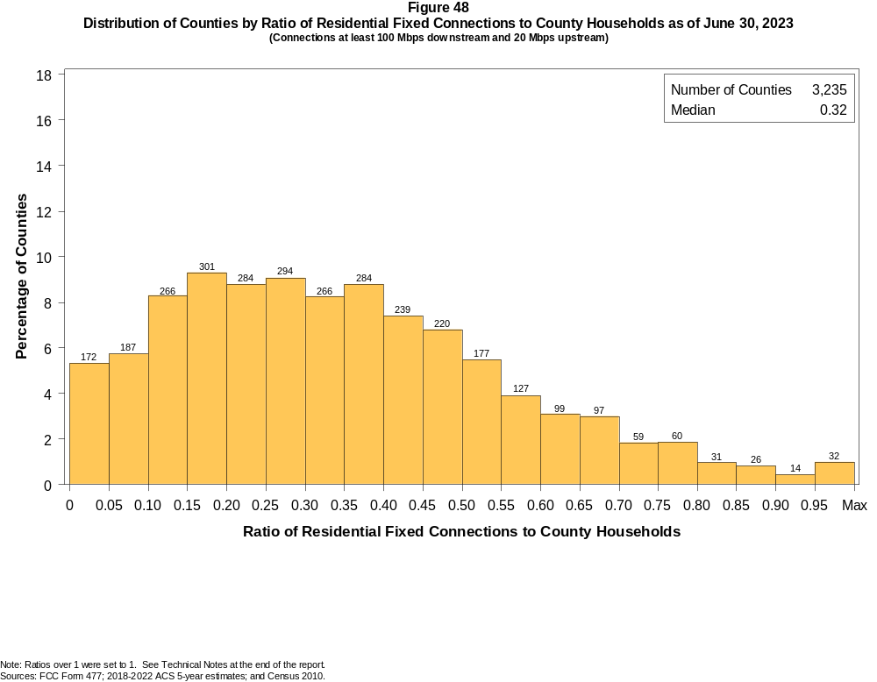

Figure 49
Distribution of Counties by Ratio of Residential Fixed Connections to Households by Technology as of June 30, 2023
(Connections at least 100 Mbps downstream and 20 Mbps upstream)

 | Ratio of Residential Fixed Connections to County Households
Technology | Zero | > 0.00  and  ≤ 0.05 | > 0.05  and  ≤ 0.10 | > 0.10  and  ≤ 0.20 | > 0.20  and  ≤ 0.30 | > 0.30  and  ≤ 0.40 | > 0.40  and  ≤ 0.50 | > 0.50  and  ≤ 0.60 | > 0.60  and  ≤ 0.80 | > 0.80  and  ≤ 1.00 | > 1.00
Total | 0.8 | 4.5 | 5.8 | 17.5 | 17.9 | 17.0 | 14.2 | 9.4 | 9.7 | 2.5 | 0.7
Copper Wire¹ | 57.5 | 38.3 | 2.8 | 1.1 | 0.2 | 0.0 | 0.0 | 0.1 | 0.0 | 0.0 | 0.0
Coaxial Cable | 14.7 | 9.9 | 14.8 | 26.7 | 17.6 | 10.0 | 4.1 | 1.3 | 0.7 | 0.1 | 0.1
Optical Carrier | 6.7 | 30.2 | 13.7 | 18.3 | 11.4 | 7.2 | 4.8 | 2.8 | 3.1 | 1.6 | 0.3
Satellite | 99.2 | 0.8 | 0.0 | 0.0 | 0.0 | 0.0 | 0.0 | 0.0 | 0.0 | 0.0 | 0.0
Fixed Wireless | 13.5 | 85.0 | 1.0 | 0.3 | 0.2 | 0.0 | 0.0 | 0.0 | 0.0 | 0.0 | 0.0
Licensed | 17.1 | 82.3 | 0.4 | 0.2 | 0.0 | 0.0 | 0.0 | 0.0 | 0.0 | 0.0 | 0.0
Unlicensed | 64.2 | 35.1 | 0.5 | 0.2 | 0.1 | 0.0 | 0.0 | 0.0 | 0.0 | 0.0 | 0.0
¹ Other is summarized with Copper Wire for confidentiality reasons.
Note: Each cell indicates the share of 3,235 counties where the ratio of residential fixed connections to households falls within the given range. Numbers may not sum to totals due to rounding.
Sources: FCC Form 477; 2018-2022 ACS 5-year estimates; and Census 2010.

Figure 50
Distribution of Counties by Ratio of Residential Fixed Connections to Households by State as of June 30, 2023
(Connections at least 100 Mbps downstream and 20 Mbps upstream)

 |  | Ratio of Residential Fixed Connections to County Households
State | Counties | Zero | > 0.00  and  ≤ 0.05 | > 0.05  and  ≤ 0.10 | > 0.10  and  ≤ 0.20 | > 0.20  and  ≤ 0.30 | > 0.30  and  ≤ 0.40 | > 0.40  and  ≤ 0.50 | > 0.50  and  ≤ 0.60 | > 0.60  and  ≤ 0.80 | > 0.80  and  ≤ 1.00 | > 1.00
Alabama | 67 | 0 | 7 | 8 | 12 | 15 | 7 | 8 | 8 | 2 | 0 | 0
Alaska | 30 | 8 | 3 | 3 | 2 | 3 | 2 | 2 | 3 | 4 | 0 | 0
American Samoa | 5 | 5 | 0 | 0 | 0 | 0 | 0 | 0 | 0 | 0 | 0 | 0
Arizona | 15 | 0 | 3 | 0 | 2 | 4 | 1 | 5 | 0 | 0 | 0 | 0
Arkansas | 75 | 0 | 4 | 1 | 9 | 17 | 18 | 12 | 4 | 8 | 2 | 0
California | 58 | 0 | 2 | 5 | 8 | 5 | 17 | 15 | 5 | 0 | 0 | 1
Colorado | 64 | 0 | 10 | 3 | 15 | 13 | 6 | 10 | 7 | 0 | 0 | 0
Connecticut | 9 | 0 | 0 | 0 | 0 | 0 | 1 | 1 | 5 | 2 | 0 | 0
Delaware | 3 | 0 | 0 | 0 | 0 | 0 | 0 | 0 | 1 | 1 | 1 | 0
District of Columbia | 1 | 0 | 0 | 0 | 0 | 0 | 0 | 0 | 1 | 0 | 0 | 0
Florida | 67 | 0 | 3 | 9 | 8 | 10 | 6 | 9 | 10 | 12 | 0 | 0
Georgia | 159 | 2 | 3 | 9 | 23 | 30 | 24 | 31 | 19 | 16 | 2 | 0
Guam | 1 | 0 | 1 | 0 | 0 | 0 | 0 | 0 | 0 | 0 | 0 | 0
Hawaii | 5 | 0 | 0 | 0 | 1 | 0 | 1 | 1 | 2 | 0 | 0 | 0
Idaho | 44 | 1 | 6 | 5 | 7 | 9 | 4 | 5 | 5 | 1 | 1 | 0
Illinois | 102 | 0 | 1 | 3 | 12 | 22 | 33 | 23 | 3 | 5 | 0 | 0
Indiana | 92 | 0 | 1 | 2 | 8 | 16 | 32 | 19 | 9 | 5 | 0 | 0
Iowa | 99 | 0 | 0 | 1 | 5 | 12 | 27 | 23 | 21 | 10 | 0 | 0
Kansas | 105 | 0 | 2 | 5 | 25 | 21 | 16 | 16 | 11 | 9 | 0 | 0
Kentucky | 120 | 0 | 0 | 6 | 23 | 22 | 24 | 19 | 9 | 11 | 6 | 0
Louisiana | 64 | 0 | 9 | 6 | 20 | 9 | 10 | 6 | 1 | 3 | 0 | 0
Maine | 16 | 0 | 0 | 1 | 12 | 1 | 2 | 0 | 0 | 0 | 0 | 0
Maryland | 24 | 0 | 0 | 0 | 0 | 2 | 2 | 4 | 5 | 8 | 3 | 0
Massachusetts | 14 | 0 | 0 | 0 | 0 | 1 | 2 | 2 | 3 | 4 | 0 | 2
Michigan | 83 | 0 | 1 | 10 | 30 | 20 | 15 | 4 | 3 | 0 | 0 | 0
Minnesota | 87 | 0 | 2 | 3 | 12 | 18 | 19 | 15 | 8 | 9 | 1 | 0
Mississippi | 82 | 0 | 12 | 5 | 9 | 7 | 13 | 16 | 11 | 9 | 0 | 0
Missouri | 115 | 0 | 14 | 9 | 25 | 13 | 17 | 14 | 9 | 12 | 1 | 1
Montana | 56 | 0 | 9 | 11 | 12 | 6 | 2 | 2 | 4 | 8 | 1 | 1
Nebraska | 93 | 0 | 10 | 5 | 11 | 12 | 19 | 20 | 12 | 3 | 1 | 0

Figure 50 - Continued
Distribution of Counties by Ratio of Residential Fixed Connections to Households by State as of June 30, 2023
(Connections at least 100 Mbps downstream and 20 Mbps upstream)

 |  | Ratio of Residential Fixed Connections to County Households
State | Counties | Zero | > 0.00  and  ≤ 0.05 | > 0.05  and  ≤ 0.10 | > 0.10  and  ≤ 0.20 | > 0.20  and  ≤ 0.30 | > 0.30  and  ≤ 0.40 | > 0.40  and  ≤ 0.50 | > 0.50  and  ≤ 0.60 | > 0.60  and  ≤ 0.80 | > 0.80  and  ≤ 1.00 | > 1.00
Nevada | 17 | 1 | 4 | 3 | 2 | 3 | 2 | 2 | 0 | 0 | 0 | 0
New Hampshire | 10 | 0 | 0 | 0 | 1 | 1 | 1 | 2 | 3 | 1 | 0 | 1
New Jersey | 21 | 0 | 0 | 0 | 0 | 0 | 1 | 2 | 3 | 13 | 1 | 1
New Mexico | 33 | 0 | 5 | 2 | 10 | 2 | 6 | 1 | 2 | 4 | 1 | 0
New York | 62 | 0 | 0 | 0 | 12 | 22 | 12 | 4 | 1 | 10 | 0 | 1
North Carolina | 100 | 0 | 1 | 1 | 21 | 27 | 18 | 14 | 8 | 5 | 4 | 1
North Dakota | 53 | 0 | 0 | 0 | 0 | 0 | 0 | 0 | 2 | 14 | 31 | 6
Northern Mariana Isl | 4 | 4 | 0 | 0 | 0 | 0 | 0 | 0 | 0 | 0 | 0 | 0
Ohio | 88 | 0 | 1 | 6 | 36 | 18 | 14 | 6 | 5 | 2 | 0 | 0
Oklahoma | 77 | 0 | 2 | 1 | 11 | 15 | 15 | 15 | 4 | 13 | 1 | 0
Oregon | 36 | 0 | 1 | 2 | 11 | 12 | 7 | 2 | 1 | 0 | 0 | 0
Pennsylvania | 67 | 0 | 0 | 0 | 5 | 11 | 14 | 15 | 11 | 10 | 1 | 0
Puerto Rico | 78 | 0 | 9 | 8 | 40 | 15 | 6 | 0 | 0 | 0 | 0 | 0
Rhode Island | 5 | 0 | 0 | 0 | 1 | 0 | 0 | 0 | 3 | 1 | 0 | 0
South Carolina | 46 | 0 | 0 | 3 | 8 | 8 | 6 | 6 | 8 | 5 | 0 | 2
South Dakota | 66 | 0 | 0 | 1 | 5 | 4 | 4 | 5 | 5 | 26 | 16 | 0
Tennessee | 95 | 0 | 0 | 2 | 9 | 13 | 17 | 13 | 17 | 19 | 3 | 2
Texas | 254 | 4 | 15 | 16 | 47 | 56 | 33 | 34 | 24 | 24 | 1 | 0
Utah | 29 | 0 | 0 | 0 | 2 | 6 | 2 | 6 | 3 | 7 | 2 | 1
Vermont | 14 | 0 | 0 | 0 | 2 | 4 | 3 | 3 | 0 | 2 | 0 | 0
Virgin Islands | 3 | 0 | 0 | 1 | 2 | 0 | 0 | 0 | 0 | 0 | 0 | 0
Virginia | 133 | 0 | 2 | 7 | 11 | 24 | 27 | 31 | 18 | 11 | 1 | 1
Washington | 39 | 0 | 3 | 3 | 5 | 9 | 12 | 3 | 1 | 2 | 0 | 1
West Virginia | 55 | 1 | 0 | 9 | 8 | 11 | 11 | 9 | 3 | 3 | 0 | 0
Wisconsin | 72 | 0 | 0 | 9 | 22 | 20 | 14 | 4 | 2 | 1 | 0 | 0
Wyoming | 23 | 0 | 0 | 3 | 5 | 9 | 5 | 0 | 1 | 0 | 0 | 0
Total | 3,235 | 26 | 146 | 187 | 567 | 578 | 550 | 459 | 304 | 315 | 81 | 22
Note: Numbers may not sum to totals due to rounding.
Sources: FCC Form 477; 2018-2022 ACS 5-year estimates; and Census 2010.

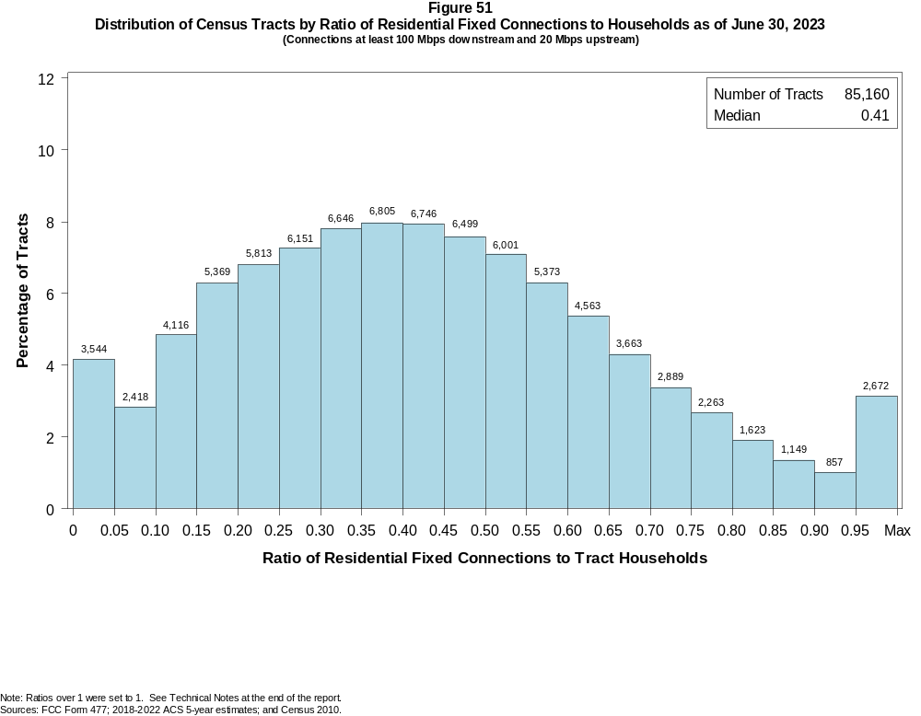

Figure 52
Distribution of Census Tracts by Ratio of Residential Fixed Connections to Households by Technology as of June 30, 2023
(Connections at least 100 Mbps downstream and 20 Mbps upstream)

 | Ratio of Residential Fixed Connections to Tract Households
Technology | Zero | > 0.00  and  ≤ 0.05 | > 0.05  and  ≤ 0.10 | > 0.10  and  ≤ 0.20 | > 0.20  and  ≤ 0.30 | > 0.30  and  ≤ 0.40 | > 0.40  and  ≤ 0.50 | > 0.50  and  ≤ 0.60 | > 0.60  and  ≤ 0.80 | > 0.80  and  ≤ 1.00 | > 1.00
Total | 1.5 | 2.7 | 2.8 | 11.1 | 14.0 | 15.8 | 15.6 | 13.4 | 15.7 | 5.0 | 2.4
Copper Wire¹ | 62.3 | 35.5 | 1.7 | 0.4 | 0.0 | 0.0 | 0.0 | 0.0 | 0.0 | 0.0 | 0.0
Coaxial Cable | 6.0 | 4.6 | 7.2 | 25.0 | 27.7 | 16.0 | 7.2 | 3.2 | 2.4 | 0.5 | 0.4
Optical Carrier | 22.8 | 18.3 | 9.6 | 15.0 | 11.7 | 8.4 | 5.6 | 3.5 | 3.1 | 1.1 | 0.8
Satellite | 100.0 | 0.0 | 0.0 | 0.0 | 0.0 | 0.0 | 0.0 | 0.0 | 0.0 | 0.0 | 0.0
Fixed Wireless | 19.9 | 77.8 | 1.6 | 0.5 | 0.1 | 0.0 | 0.0 | 0.0 | 0.0 | 0.0 | 0.0
Licensed | 21.5 | 77.1 | 1.1 | 0.2 | 0.0 | 0.0 | 0.0 | 0.0 | 0.0 | 0.0 | 0.0
Unlicensed | 92.5 | 6.8 | 0.4 | 0.2 | 0.1 | 0.0 | 0.0 | 0.0 | 0.0 | 0.0 | 0.0
¹ Other is summarized with Copper Wire for confidentiality reasons.
Note: Each cell indicates the share of 85,160 Census Tracts where the ratio of residential fixed connections to households falls within the given range. Numbers may not sum to totals due to rounding.
Sources: FCC Form 477; 2018-2022 ACS 5-year estimates; and Census 2010.

Figure 53
Distribution of Census Tracts by Ratio of Residential Fixed Connections to Households by State as of June 30, 2023
(Connections at least 100 Mbps downstream and 20 Mbps upstream)

 |  | Ratio of Residential Fixed Connections to Tract Households
State | Tracts | Zero | > 0.00  and  ≤ 0.05 | > 0.05  and  ≤ 0.10 | > 0.10  and  ≤ 0.20 | > 0.20  and  ≤ 0.30 | > 0.30  and  ≤ 0.40 | > 0.40  and  ≤ 0.50 | > 0.50  and  ≤ 0.60 | > 0.60  and  ≤ 0.80 | > 0.80  and  ≤ 1.00 | > 1.00
Alabama | 1,435 | 15 | 91 | 78 | 205 | 243 | 204 | 189 | 145 | 181 | 60 | 24
Alaska | 177 | 27 | 16 | 8 | 6 | 5 | 19 | 17 | 31 | 38 | 5 | 5
American Samoa | 18 | 18 | 0 | 0 | 0 | 0 | 0 | 0 | 0 | 0 | 0 | 0
Arizona | 1,765 | 79 | 114 | 114 | 443 | 414 | 226 | 126 | 89 | 109 | 27 | 24
Arkansas | 823 | 3 | 40 | 38 | 128 | 138 | 109 | 123 | 96 | 106 | 34 | 8
California | 9,107 | 98 | 149 | 130 | 602 | 1,394 | 2,062 | 1,975 | 1,440 | 1,015 | 159 | 83
Colorado | 1,447 | 22 | 66 | 34 | 119 | 222 | 369 | 288 | 178 | 117 | 20 | 12
Connecticut | 879 | 6 | 1 | 0 | 21 | 101 | 112 | 128 | 165 | 266 | 69 | 10
Delaware | 259 | 3 | 0 | 1 | 1 | 11 | 20 | 43 | 44 | 69 | 38 | 29
District of Columbia | 206 | 2 | 0 | 0 | 1 | 12 | 33 | 34 | 50 | 52 | 12 | 10
Florida | 5,114 | 52 | 93 | 91 | 364 | 632 | 793 | 904 | 790 | 870 | 304 | 221
Georgia | 2,791 | 23 | 49 | 67 | 194 | 297 | 377 | 426 | 417 | 684 | 224 | 33
Guam | 56 | 15 | 37 | 2 | 1 | 0 | 0 | 0 | 0 | 0 | 0 | 1
Hawaii | 436 | 17 | 5 | 3 | 9 | 48 | 74 | 84 | 72 | 81 | 19 | 24
Idaho | 456 | 3 | 42 | 18 | 35 | 35 | 39 | 75 | 76 | 103 | 15 | 15
Illinois | 3,263 | 10 | 56 | 39 | 252 | 591 | 847 | 715 | 474 | 251 | 23 | 5
Indiana | 1,693 | 13 | 20 | 42 | 143 | 267 | 395 | 337 | 238 | 191 | 33 | 14
Iowa | 896 | 5 | 13 | 29 | 69 | 84 | 114 | 143 | 164 | 209 | 59 | 7
Kansas | 829 | 15 | 20 | 89 | 118 | 104 | 97 | 91 | 75 | 147 | 57 | 16
Kentucky | 1,306 | 15 | 42 | 56 | 173 | 174 | 207 | 194 | 173 | 199 | 60 | 13
Louisiana | 1,376 | 66 | 90 | 121 | 280 | 185 | 191 | 190 | 117 | 111 | 20 | 5
Maine | 400 | 2 | 11 | 26 | 180 | 111 | 29 | 25 | 10 | 4 | 2 | 0
Maryland | 1,463 | 7 | 6 | 2 | 21 | 92 | 165 | 235 | 254 | 418 | 166 | 97
Massachusetts | 1,613 | 20 | 3 | 6 | 92 | 123 | 177 | 273 | 328 | 406 | 125 | 60
Michigan | 2,971 | 84 | 63 | 116 | 478 | 604 | 633 | 579 | 275 | 110 | 20 | 9
Minnesota | 1,502 | 8 | 44 | 47 | 193 | 414 | 301 | 183 | 118 | 137 | 42 | 15
Mississippi | 875 | 13 | 69 | 55 | 90 | 96 | 108 | 102 | 95 | 174 | 65 | 8
Missouri | 1,654 | 20 | 134 | 66 | 171 | 180 | 241 | 241 | 235 | 274 | 68 | 24
Montana | 319 | 16 | 46 | 31 | 96 | 59 | 19 | 12 | 9 | 20 | 5 | 6
Nebraska | 553 | 3 | 21 | 22 | 91 | 98 | 90 | 80 | 66 | 75 | 4 | 3

Figure 53 - Continued
Distribution of Census Tracts by Ratio of Residential Fixed Connections to Tract Households by State as of June 30, 2023
(Connections at least 100 Mbps downstream and 20 Mbps upstream)

 |  | Ratio of Residential Fixed Connections to Tract Households
State | Tracts | Zero | > 0.00  and  ≤ 0.05 | > 0.05  and  ≤ 0.10 | > 0.10  and  ≤ 0.20 | > 0.20  and  ≤ 0.30 | > 0.30  and  ≤ 0.40 | > 0.40  and  ≤ 0.50 | > 0.50  and  ≤ 0.60 | > 0.60  and  ≤ 0.80 | > 0.80  and  ≤ 1.00 | > 1.00
Nevada | 775 | 9 | 19 | 31 | 171 | 220 | 144 | 79 | 36 | 39 | 17 | 10
New Hampshire | 349 | 3 | 2 | 7 | 21 | 25 | 34 | 69 | 87 | 66 | 15 | 20
New Jersey | 2,175 | 11 | 11 | 8 | 19 | 50 | 117 | 222 | 468 | 840 | 261 | 168
New Mexico | 612 | 39 | 63 | 41 | 197 | 140 | 46 | 38 | 14 | 22 | 9 | 3
New York | 5,393 | 140 | 17 | 50 | 744 | 506 | 503 | 508 | 803 | 1,410 | 486 | 226
North Carolina | 2,660 | 29 | 36 | 66 | 401 | 432 | 358 | 346 | 279 | 413 | 181 | 119
North Dakota | 228 | 2 | 0 | 0 | 0 | 0 | 1 | 7 | 17 | 78 | 92 | 31
Northern Mariana Isl | 23 | 23 | 0 | 0 | 0 | 0 | 0 | 0 | 0 | 0 | 0 | 0
Ohio | 3,162 | 14 | 51 | 133 | 662 | 551 | 499 | 466 | 358 | 349 | 63 | 16
Oklahoma | 1,205 | 20 | 61 | 63 | 180 | 199 | 212 | 151 | 119 | 135 | 50 | 15
Oregon | 994 | 7 | 26 | 35 | 180 | 222 | 184 | 154 | 136 | 39 | 9 | 2
Pennsylvania | 3,445 | 47 | 25 | 48 | 169 | 283 | 496 | 707 | 595 | 720 | 247 | 108
Puerto Rico | 939 | 55 | 122 | 133 | 291 | 153 | 104 | 40 | 21 | 12 | 5 | 3
Rhode Island | 247 | 1 | 1 | 1 | 19 | 10 | 25 | 75 | 56 | 41 | 13 | 5
South Carolina | 1,317 | 21 | 35 | 44 | 185 | 176 | 186 | 172 | 159 | 182 | 90 | 67
South Dakota | 242 | 0 | 2 | 2 | 12 | 10 | 15 | 10 | 22 | 82 | 68 | 19
Tennessee | 1,701 | 26 | 17 | 26 | 194 | 239 | 251 | 255 | 240 | 323 | 101 | 29
Texas | 6,883 | 73 | 196 | 182 | 628 | 696 | 848 | 1,016 | 984 | 1,449 | 551 | 260
Utah | 716 | 9 | 6 | 7 | 47 | 84 | 118 | 122 | 119 | 131 | 49 | 24
Vermont | 193 | 2 | 11 | 8 | 26 | 21 | 50 | 29 | 17 | 16 | 4 | 9
Virgin Islands | 29 | 0 | 6 | 8 | 12 | 3 | 0 | 0 | 0 | 0 | 0 | 0
Virginia | 2,186 | 34 | 49 | 36 | 173 | 310 | 275 | 337 | 307 | 384 | 171 | 110
Washington | 1,772 | 17 | 57 | 31 | 143 | 373 | 514 | 331 | 164 | 102 | 12 | 28
West Virginia | 546 | 10 | 34 | 26 | 60 | 69 | 97 | 105 | 73 | 67 | 5 | 0
Wisconsin | 1,526 | 6 | 69 | 93 | 329 | 404 | 298 | 184 | 74 | 57 | 6 | 6
Wyoming | 160 | 1 | 8 | 8 | 46 | 54 | 25 | 10 | 2 | 4 | 2 | 0
Total | 85,160 | 1,279 | 2,265 | 2,418 | 9,485 | 11,964 | 13,451 | 13,245 | 11,374 | 13,378 | 4,242 | 2,059
Note: Numbers may not sum to totals due to rounding.
Sources: FCC Form 477; 2018-2022 ACS 5-year estimates; and Census 2010.

